### SCS 3214 / IS 3113: Group Project II - 2021

**Interim Report**

**Project Title: Electro-Sustainable Electricity Model for Domestic Users**

**Project Group Details**

1. Group number: **G11**
2. Group members:

|  |  |  |  |  |
| --- | --- | --- | --- | --- |
| ***Name*** | ***Reg. Number*** | ***Index Number*** | ***Email address*** | ***Mobile Phone*** |
| (i) T.W.T.Dulshan | 2018/CS/048 | 18000487 | tdwithanage97@gmail.com | 0711565953 |
| (ii) W.M.D.M.Y.Wickramanayaka | 2018/CS/192 | 18001922 | yasarawickramanayaka@gmail.com | 0769226787 |
| (iii) A.V.Abeysuriya | 2018/CS/005 | 18000053 | asikaabeysuriya456@gmail.com | 0715634670 |
| (iv) W.K.B.K.Madhushanka | 2018/CS/096 | 18000967 | buthsaramadhushanka@gmail.com | 0783446516 |
| (v) H.A.H.Vidushanka | 2018/IS/086 | 18020862 | hasinividushanka@gmail.com | 0766065684 |

**Details of Project Supervisor, Co-supervisor, Advisors and Clients**

**Project Supervisor (Academic Staff of UCSC):**

Name of the supervisor: **Dr.Dinuni Fernando**

Signature of the supervisor:

Date: 12/07/2021

**Project Co-Supervisor (Assigned by Course Coordinator):**

Name of the co-supervisor: **Mr.Akila Gamage**

Signature of the co-supervisor:

Date:12/07/2021

**The client of the Project (If applicable, otherwise supervisor will be considered as the client)**

Name of the client: Dr. Dinuni Fernando

e-mail address of the contact person: [dkf@ucsc.cmb.ac.lk](mailto:dkf@ucsc.cmb.ac.lk)

**Table of Contents**

SCS 3214 / IS 3113: Group Project II - 2021 1

Project Details 5

1) Project Title 5

2) The Goal and Objectives 5

Objectives 5

3) Problem Definition 6

4) A brief introduction to the project 7

Proposing algorithm 8

Motivation 8

Similar/Related Projects 8

5) The scope of the project 9

Users (possible actors) of the system 9

Main functionalities of the system 9

Out of the Scope 10

6) Feasibility Study 10

6.1 Operational Feasibility 10

6.2 Schedule Feasibility 12

6.3 Legal Feasibility 12

6.4 Economic Feasibility 13

6.5 Technical Feasibility 13

7) Systems Architecture 14

8) Requirements Specification 15

8.1 Use Case Diagram 15

8.2 ER Diagram 16

8.3 Component Diagram 17

8.4 Class Diagram 19

8.5 UI Flow Diagrams 20

8.5.1 Login UI flow 20

8.5.3 Admin UI flow 21

8.5.4 CEB engineer UI flow 22

9) User Interfaces 23

9.1 For All Users 23

9.1.1 Sign-in 23

9.1.3 Sign-up 24

9.1.4 Forgot Password 24

9.1.1 Home 25

9.2 Customer 26

9.2.1 Dashboard 26

9.2.2 Creating a new bill plan 26

9.2.3 Bill Comparison 27

9.2.4 Devise Wise Usage 28

➢ TOU 28

➢ Fixed 30

9.2.5 TOU Suggestions 31

9.2.6 My Bill Plans 32

9.2.7 My Bill Plans-More Details 33

9.2.8 Special Events 34

9.2.9 Special Events-More Details 35

9.2.10 Information Page 36

9.3 Admin 36

9.3.1 Dashboard 36

9.3.2 Managing Unit Charges Home 37

9.3.3 UI for updating unit charges 37

9.3.4 Pop up window when updating unit charges 38

9.3.6 Updating CEB Engineer details 39

9.3.7 Updating User profile 39

9.4 CEB Engineer 40

9.4.1 Dashboard 40

9.4.2 Pop up window when updating unit charges 40

9.4.3 User Profile 41

10) Main deliverables of the system 41

11) The Project Plan 42

Work Breakdown Structure 42

12) References 44

13) Declaration 45

# Project Details

# Project Title

Electro - Sustainable Electricity Model for Domestic Users

# The Goal and Objectives

Our end goal of the project is to introduce a sustainable electricity model for domestic household users to select between normal electricity billing model with TOU (Time of Use) model, where our proposed system will provide suggestions to further reduce electricity usage when the TOU method is selected as the best and most applicable electricity consumption model to reduce the electricity bill value. And eventually, our proposed solution will help to reduce the energy crisis in the country.

## Objectives

* To provide a better understanding about the way how the electricity bill is calculated for the local domestic electricity users.
* To give suggestions about how to reduce the electricity bill when using the TOU plan based on domestic electricity consumption.
* To make a sustainable model where users can select their corresponding method on electricity billing based on their need and usage.
* To make the model more ‘user friendly by creating simple and efficient user interfaces.
* To support domestic users to work according to a time frame in order to reduce power consumption.
* To give a better understanding for the users about their device wise usage using graphical charts.
* To minimize the loss happen to the electricity board by promoting the TOU Plan to the consumers.

# Problem Definition

In Sri Lanka, there are two models to calculate the electricity bill for domestic householders[1][2].

1. The electricity connection that charges based on the number of units of consumption (Block) [1].
2. The electricity connection that charges based on the time of use (Time of Use (TOU))[2].

Most of the electricity users in Sri Lanka have the fixed unit billing method to calculate their electricity bill where electricity consumption cost is calculated using a fixed charge based on the consumed units. This fixed bill calculation is the default billing cycle for household consumers. However, there exists another approach called Time of Use (TOU), where electricity consumption is calculated for each month considering power usage in peak, off-peak and day-time charges. As TOU is an additional approach where consumers have to enroll, the TOU method is less popular among household consumers due to unawareness. Not every user can benefit from the TOU method or fixed billing unless the consumer estimates his/her consumption manually. Further,there is no proper platform/ tool to check the most suitable billing method to use considering electrical devices anticipated to be used in the household. Furthermore, there is no mechanism to get clues/suggestions and predictions about bill predictions based on the using billing method to further minimize the value of the bill without limiting the usage of electrical units by using the TOU method.

When the **number of electric devices is increasing** in a particular household, it will be extremely difficult for users to regulate their electric equipment device-by-device in order to reduce their electricity bills. At the same time, it will be quite difficult for the consumers to calculate the amount that can be saved and the effect that may happen for their bill device-by-device.

# A brief introduction to the project

Our Proposed system will consist of a mobile responsive web application where users can use whichever electricity calculation method is handy for them based on their consumption. After a particular user logs in to the system, they can select a list of electric items they have in their house and enter its power(in Watt) and the electricity usage of corresponding items. When getting inputs from the users, we will be setting a priority level for the devices according to the usage necessity. It means that users have to prioritize the devices which they can switch the usage from the Peak time period to the Off-Peak time. (Example: When we have a rice cooker at home which we can not switch the usage time, we have to give a high priority not to change the device usage time. And if we use an iron which we can switch the usage time to, we have to give less priority to it) Then the system will automatically calculate the monthly bill considering both the fixed unit billing method and the Time of Use (TOU) method as proposed in our system.

If the TOU method is identified as the best method for the consumers, we will be providing suggestions to further reduce electricity consumption by incorporating our proposed scheduling algorithm. When giving suggestions, we will be showing the consumers how much they can save by each device. Finally, we will show the total amount which consumers can save according to the given suggestions and further users are able to visualize their savings using charts.

Using our system, users can get a proper understanding about the electric usage of each individual device separately and what portion of the bill is allocated for a particular device by using both methods. So the consumers can get an idea about which device consumes more electricity units. Consumers can also get their future predicted electricity usage, if they have a special event in their home where they have to use more electricity. So they can get an idea about the bill in that specific month to check whether that amount is feasible to them or not and plan accordingly.

When we register a user to the system, all the details given by that user will be saved to the system. So that, the users do not have to enter the same details about the electric devices which they have in their house when calculating the bill in future months once again. (Example: When the user got a new electric guitar, he only has to enter the details about that new device when calculating the bill, as the details entered about the previous devices are already saved in the system)

## Proposing algorithm

The heart of the proposed system lies in the proposing scheduling algorithm that tries to schedule electrical equipment in an optimal manner which can be beneficial to the consumers to further reduce their energy consumption.

* With the growing need of electrical devices, our proposing algorithm tries to schedule them considering the urgency level (high priority / high urgency-in this case device need to use during the specified time by the user, mid priority / mid urgency-device can use moderately in the specified time period, low priority / low urgency-device usage is not mandatory in the specified time period, it can move to any low-cost time slot).
* As scheduling algorithm complexity is in the NP domain (with the growth of the electrical instruments), we are proposing an algorithm that considers a heuristic-based scheduling algorithm that considers urgency level, operating time interval, and power usage into account. Our heuristic algorithm will produce results in polynomial time as the electrical instruments in a usual household do not increase exponentially.

## Motivation

Energy consumption is a tremendous challenge in a country as well as the world since the demand for electricity usage grows day by day. Our proposed model will support countries’ energy crisis by reducing peak electricity usage hours and help the users to consume electricity mindfully. And also, this system, it will minimize the loss that may happen to the electricity board by promoting the Tariff plan to the consumers.

## Similar/Related Projects

We have found a related project named ‘CEB Care’[3]. It has the following features.

* Lodge Electricity Complaint
* Manage Multiple Electricity Accounts
* Interruption Alerts
* Interruption Calendar
* Check Bill Information
* Check Payment Information
* Make Online Payment
* Usage Estimation
* Bill Calculator

However, our focus is to compare the fixed model with the TOU(time of use) and provide suggestions to reduce electricity consumption. so the ideas and focus of the two projects are quite different. And also, the application which we are introducing mainly focuses on giving suggestions by proposing a scheduling algorithm that tries to schedule electrical equipment in an optimal manner which can be beneficial to the consumers to further reduce their energy consumption when they use the TOU(Time of Use) model.

# The scope of the project

We are proposing a mobile responsive web application that will calculate the electricity consumption of domestic household users based on the unit-based model and TOU model. Furthermore, our system will provide suggestions to choose the best model based on electricity consumption and further reduce unnecessary electricity usage.

## Users (possible actors) of the system

* Admin
* Users
* CEB Engineer

## Main functionalities of the system

Common for all the user roles

* Login
* Logout
* Updating the user profile
* View the electricity unit charges for both the Fixed model and TOU model

Users

* View their calculated monthly bill using both the Fixed model and TOU model.
* View the device wise usage using charts for both methods in the monthly bill plan as well as in the special events plan.
* View the suggestions to reduce their electricity bills for the TOU model.
* Manage (Add/Update/Delete/View) monthly electricity bill plan details using both models.
* Manage (Add/Update/Delete/View) special events bill plan details for a specific time period using both models.

Admin

* Managing unit charges received by CEB Engineer
* Adding a new CEB Engineer to the system
* Deactivating an available CEB Engineer from the system
* Updating details of the available CEB Engineers in the system

CEB Engineer

* Informing about the changes of the unit prices to the admin

## Out of the Scope

* The current system will only be limited to handle domestic household usage.
* We are only calculating the bill according to the details given by the user(Ex: Power of the electric item).

# Feasibility Study

## 6.1 Operational Feasibility

This measures how well our solution satisfies the problem stated above and how well it addresses the requirements stated.

After conducting a survey and collecting ideas from more than 170 individuals, we got to know that over 90% of participants from the lot liked to have a web application/mobile app to calculate their electricity bill according to the electric items they have in their houses and to get tips to reduce their monthly electricity bill.

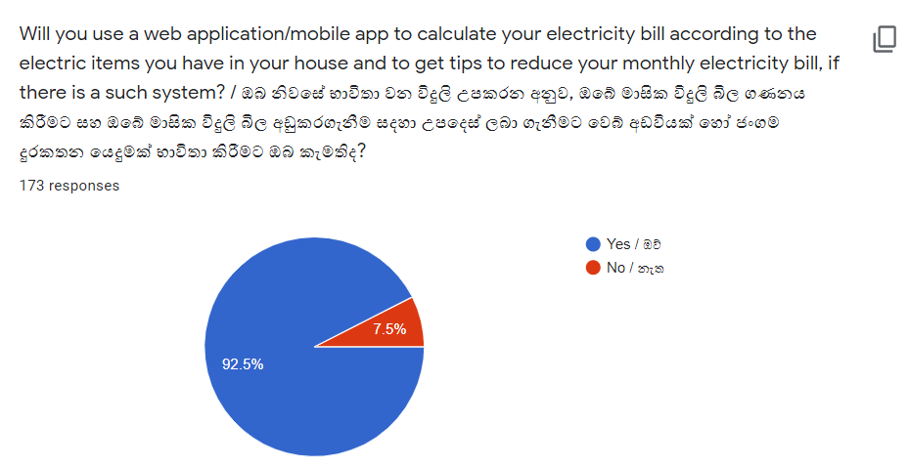

And also, we got to know that over 80% of participants of the survey use electricity at night time where the government spends more money to produce one electric unit which is higher than the price the government charges from the consumers for one unit.

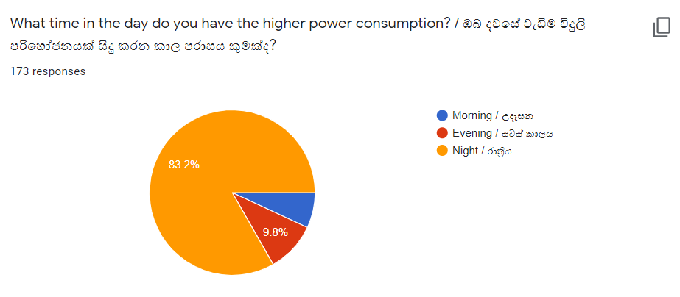

According to the survey, 80% of the participants do not know about the TOU method where users can reduce their electricity bills when using this method.

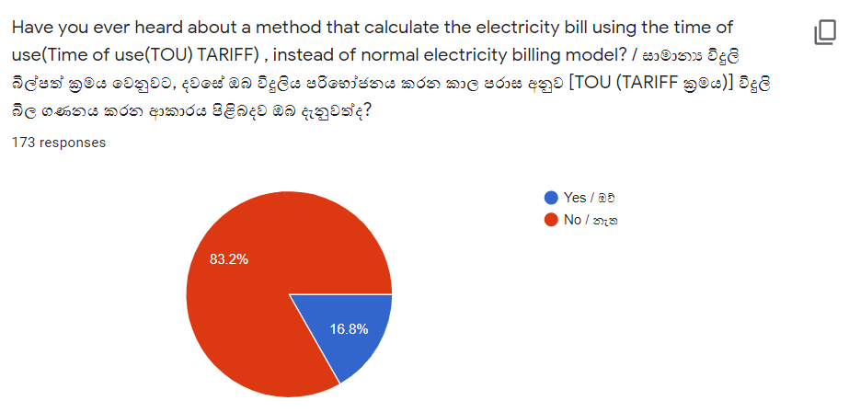

By our proposed system, we introduce a sustainable electricity model, where domestic users can select which method is most suitable for them between the normal billing method and the TOU method. This will also help users to be aware of the TOU method while getting suggestions to reduce the electricity bill.

Considering all the facts mentioned above, we can assure that our project is operationally feasible.

## 6.2 Schedule Feasibility

This measures how reasonable the project timeline is. We have gathered most of the requirements when it comes to the functionalities and will be continuing the same with other possible requirements while developing the system.

As the requirements are gathered already, we hope to design the system whilst discovering methods to enhance the user experience of the system.

We will be planning to do the development and testing parts according to the timeline we came up with. So, by the end of this semester, we think we can implement the system as scheduled in our timeline.

There can be exceptions because of the current situation in the country. But we will be working hard to stick to the timeline and develop the system according to the timeline we provided. Our plan is to finish the development of the project by the end of this semester(September). With the resources we have and the requirements gathering and analysis we have done, we will be succeeding in completing the project on time. And also, there are 5 members in the group, so there is adequate time to complete our project. So, we can assure the schedule we are following is feasible.

## 6.3 Legal Feasibility

This is a measure of how our system can be implemented within existing legal and contractual obligations.

We can assure that the system security is really high for the users of this system and also we can assure that by the system or by using the system there will be no ethical / privacy issues or legal issues that will occur.

**End-User Privacy**

When the customers sign up or log in to the system, no sensitive information will be collected from the customer. (No IP address tracking, email tracking or directing to unauthorized websites)

**Government rules & regulations**

The developer has the sole authority over the system. So, there will be no issues when it comes to this aspect.

Therefore, we can claim that the system is legally feasible.

## 6.4 Economic Feasibility

This is the part where we measure the cost-effectiveness of the project. First and foremost the developing part of the system will not be costly, as the developers are undergraduates with a purpose and will not be considering using tools that have to be purchased or paid. So the developing part will be cost-free. And also, we have to bear a considerable amount of cost as the project communication cost because of the current Covid-19 situation, we are forced to use distance communication via zoom meetings and mobile phones. We planned to use our own hardware equipment. Hence there is no additional hardware cost for the project. The cost of the paperwork is reduced by using the electronic media(notebook, MS office)

Since there are no considerable expenses, the project is economically feasible.

## 6.5 Technical Feasibility

This is a measure of the practicality of the technical solutions and the availability of technical expertise.

The system will be implemented as a mobile responsive web application.

The front end of the mobile app will be developed using React Native while the front end of the web application will be developed using Reactjs.

For the back-end of the system, we will be using Nodejs and for the database, we will be using MYSQL whilst Git and GitHub will be used for the version controlling aspect. And also we will be using Visual Studio Code as our IDE, Microsoft Office and Grammarly[4] for the Tools and Utilities. Furthermore, we will be using Figma[5] as our collaborative interface designing tool and Draw.io[6] for drawing the UML diagrams. All the above-mentioned technologies are the ones all five members are familiar with and have worked with so far. All the technologies we will be using are freely available on the web.

Apart from that, we are planning to adapt to new technologies meanwhile to enhance the development of the system as all the team members have similar skill-sets. Hence our project is technically feasible.

With all these five feasibility in check, we can safely assume that this is a feasible project in both the long and short run, thus we should proceed further with the development of this system.

# Systems Architecture

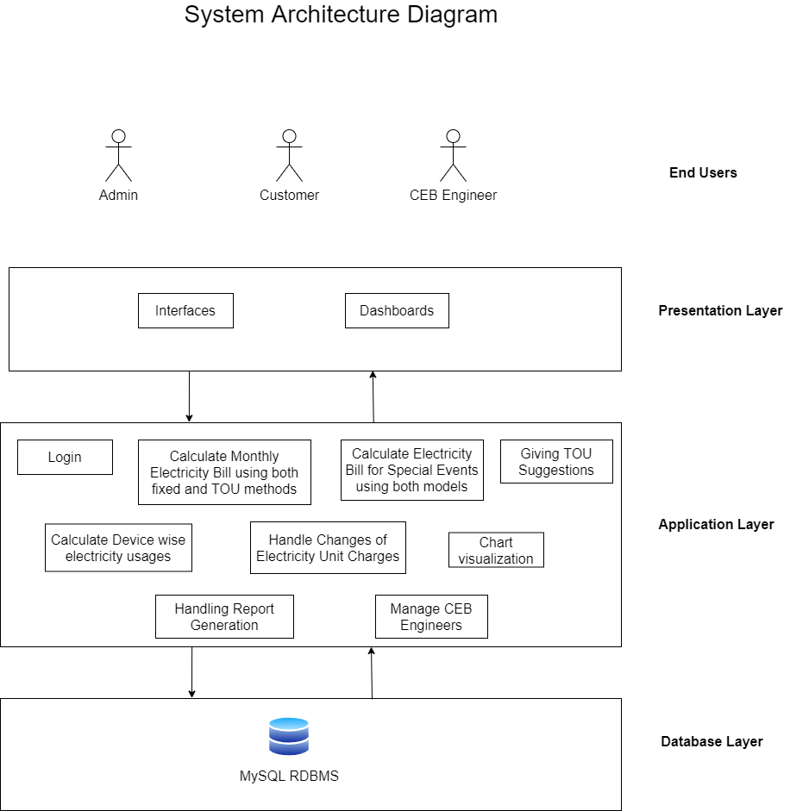

# Requirements Specification

## 8.1 Use Case Diagram

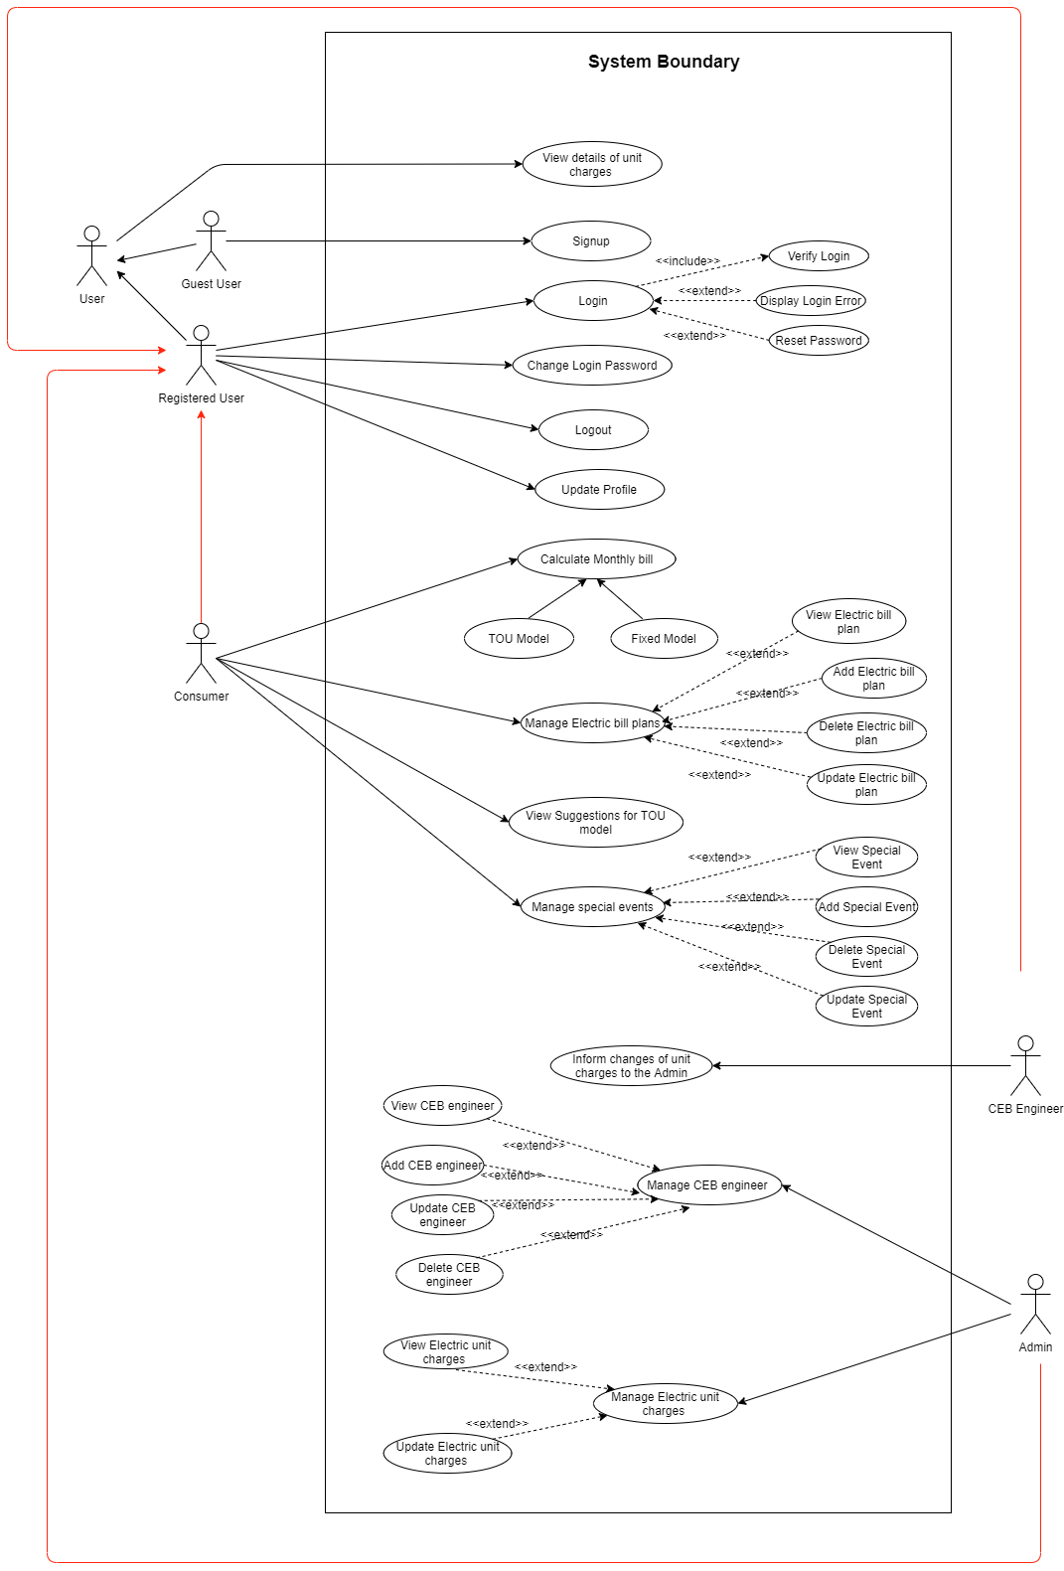

## 8.2 ER Diagram

## 8.3 Component Diagram

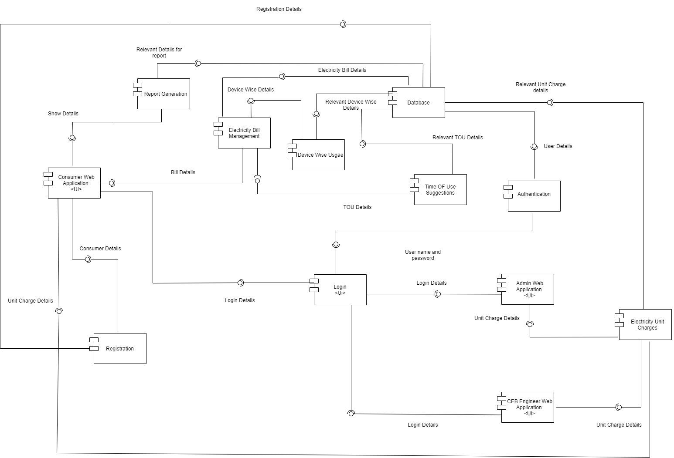

|  |  |
| --- | --- |
| **Component** | **Description** |
|  | This component initializes the registration process and registers new consumers to the system. |
|  | This UI component supplies the system access for the consumers, admin and CEB engineers. This will get the login details from the users and connect with the authentication process to verify the users and give them access to the system. |
|  | This component will fetch the user id and password from the database and verify users when they give login details to the system. |
|  | This UI component represents the consumer role of the system. Consumers of the system can manage their bill plans and view device-wise usage details of every plan. |
|  | This UI component represents the admin role of the system. Admin of the system can add/update/remove/view the details of the CEB engineers. And also, the admin will be the one who manages the unit charge detail updates received by the CEB engineer. |
|  | This UI component represents the CEB engineer role of the system. CEB engineers can inform about the changes of the unit prices to the admin. |
|  | This component represents the electricity unit charge details of the system. This component fetches data from the database component. When admin updates unit charge details and CEB engineers inform about unit charge details, that processes happen through this component. |
|  | This UI component represents the TOU suggestions for the devices. This will fetch the details related to the TOU model from the database and give suggestions to reduce the electricity bill. |
|  | This UI component represents the device-wise usage details of the system. According to the details given by the users about their electric devices, this will fetch those details from the database and help to show the device-wise usage details graphically for the consumers. |
|  | This UI component represents the electricity bill management of the system. This will manage the details of the Time of Use model and the details of the Normal billing method and helps to calculate the bill for the consumers in both methods. |
|  | This UI component represents the report generation part of our system. This will be generating reports containing the TOU suggestions for the consumers upon the consumer’s request. |
|  | This UI component represents the database of the system. The database holds all the system data related to consumers, admin, CEB engineers all the other system functional information. |

## 8.4 Class Diagram

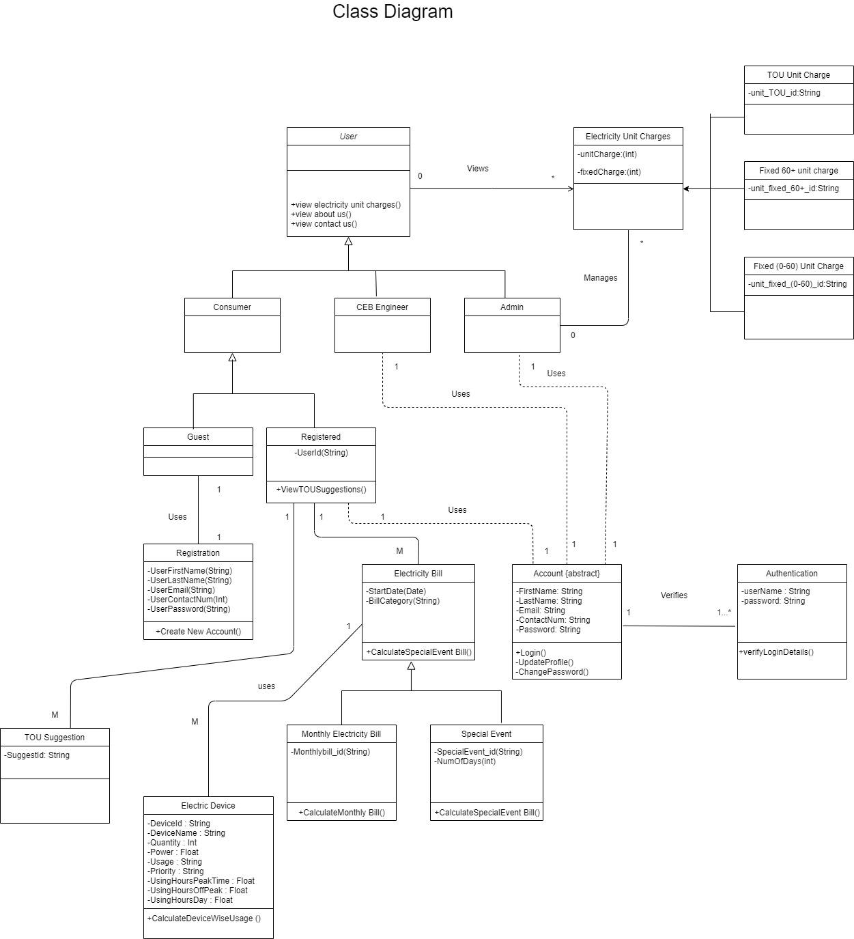

## 8.5 UI Flow Diagrams

### 8.5.1 Login UI flow

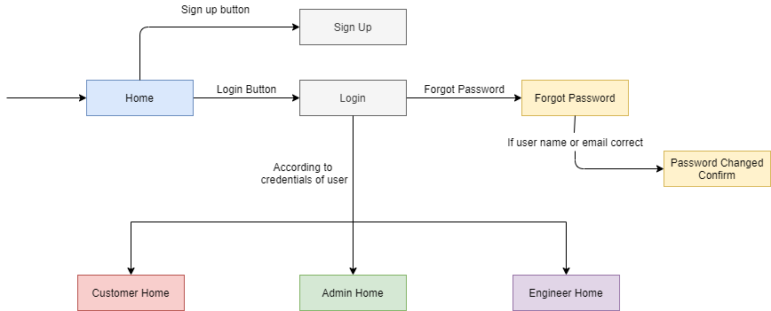

#### 8.5.2 Customer UI flow

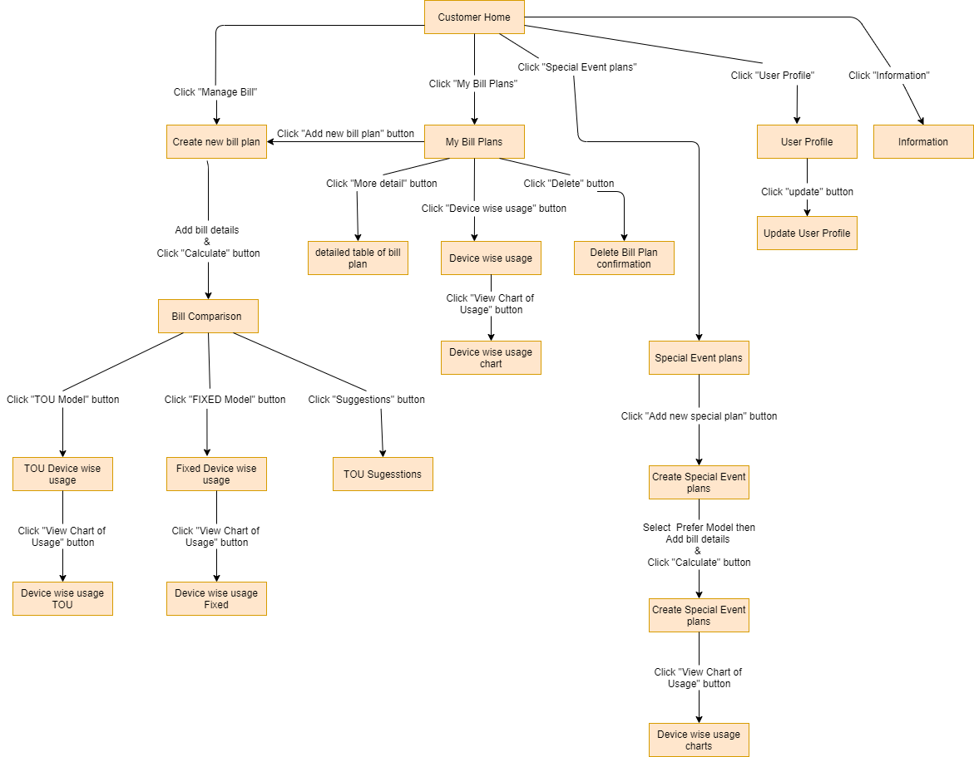

### 8.5.3 Admin UI flow

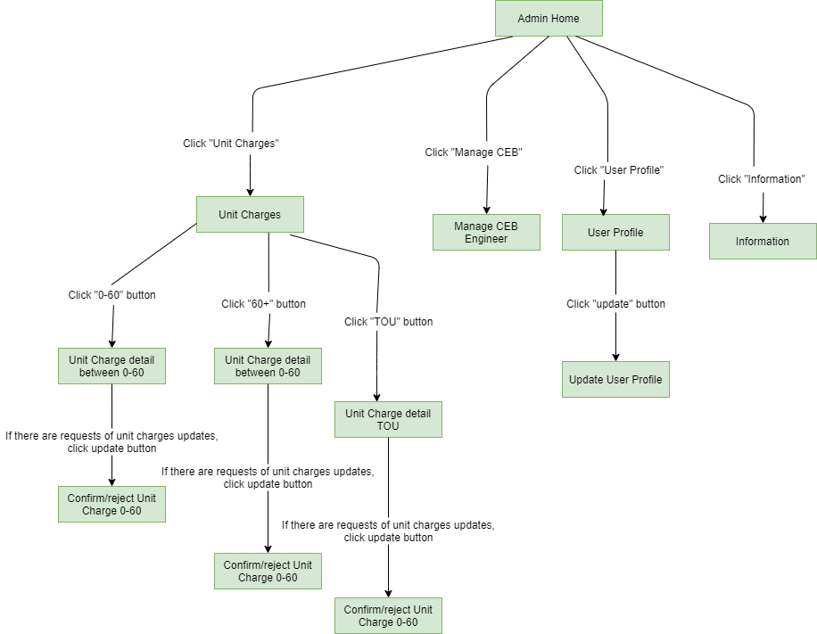

### 8.5.4 CEB engineer UI flow

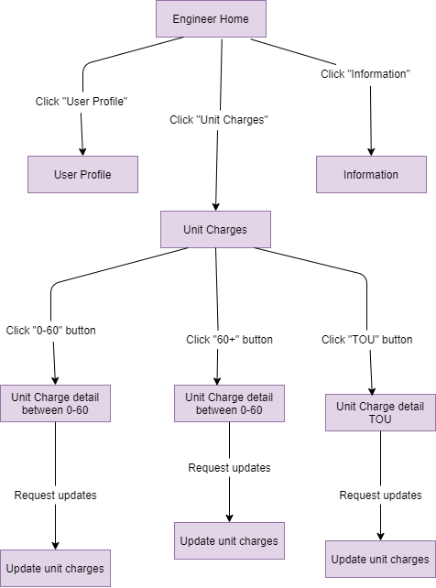

# User Interfaces

* We used a simple design to create our user interfaces to make it easier for users to engage with our system.
* We used buttons and several other options to limit the number of actions required to perform a task by the users and to prevent making users think too hard to achieve a required goal.
* We tried to avoid using new terms for our system and used words that are using commonly in other applications. It makes users think less when a user has to do a particular task using our system.

All the UI we created are added below in order to elaborate on the above-mentioned points.

## 9.1 For All Users

### 9.1.1 Sign-in

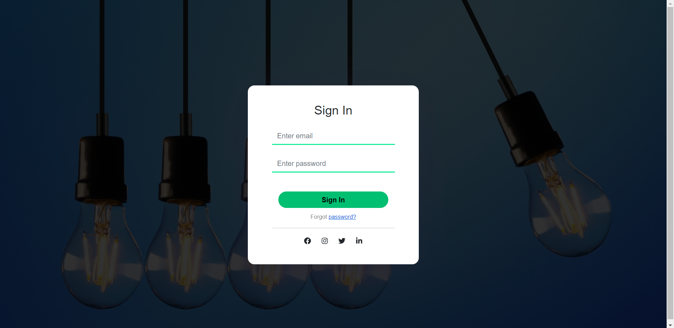

### 9.1.3 Sign-up

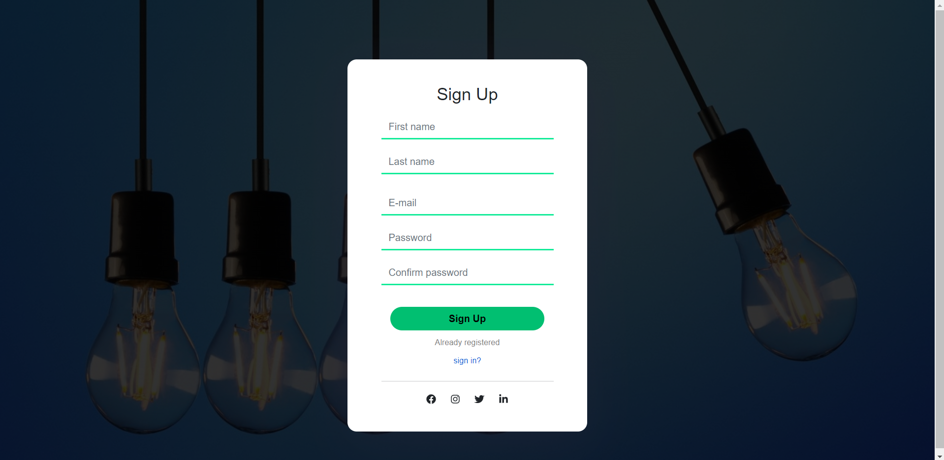

### 9.1.4 Forgot Password

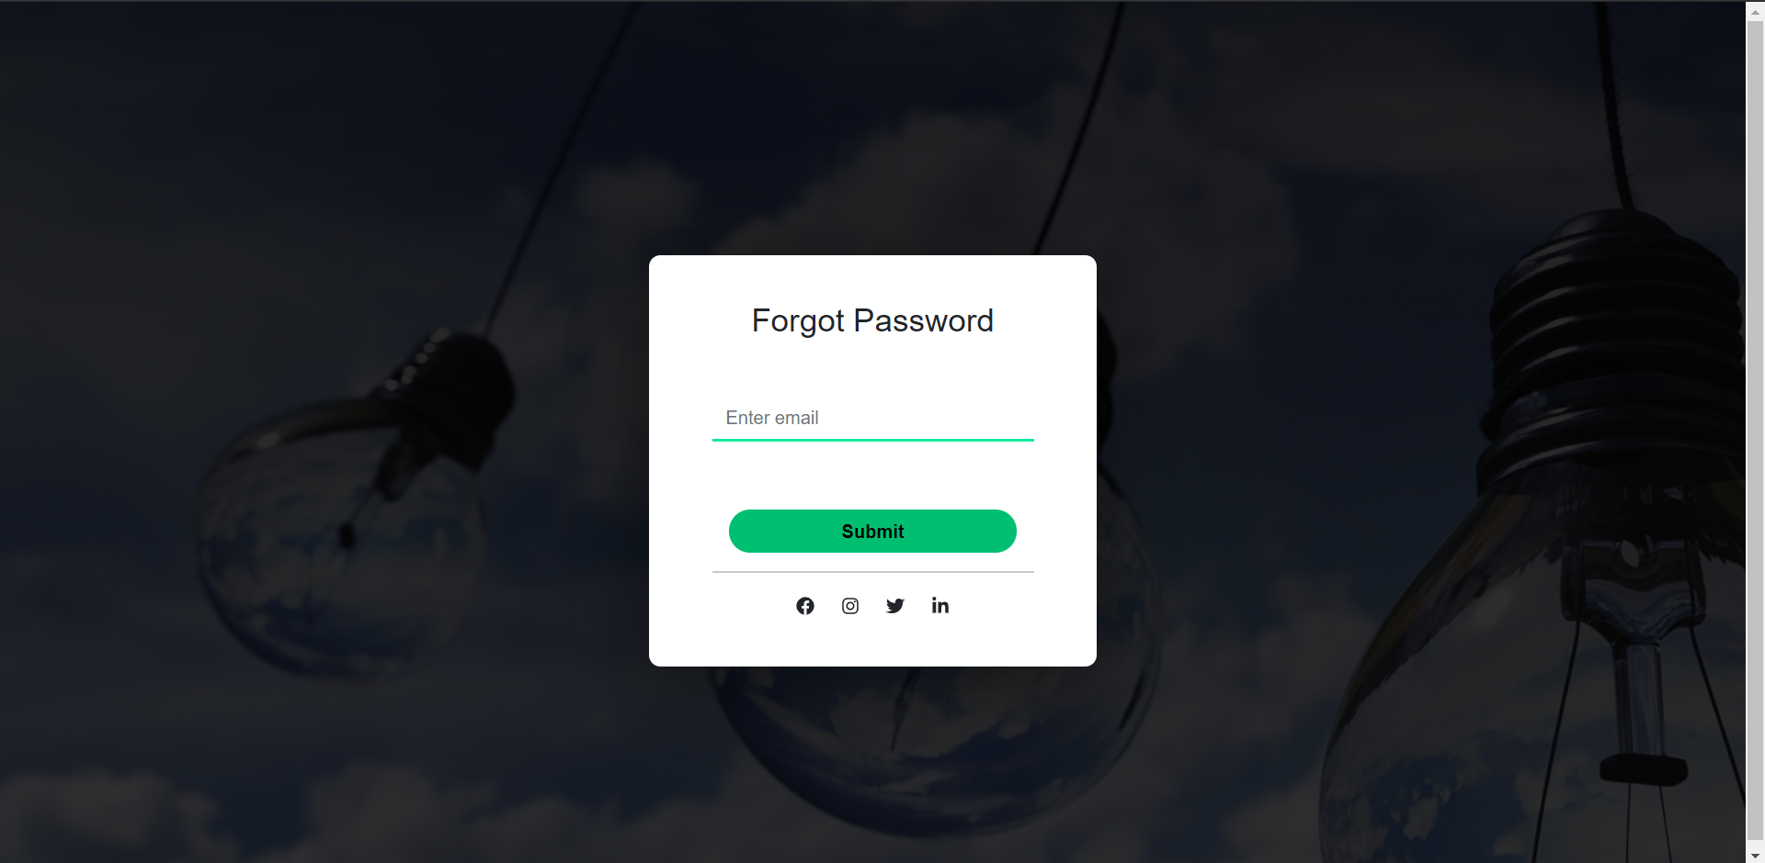

### 9.1.1 Home

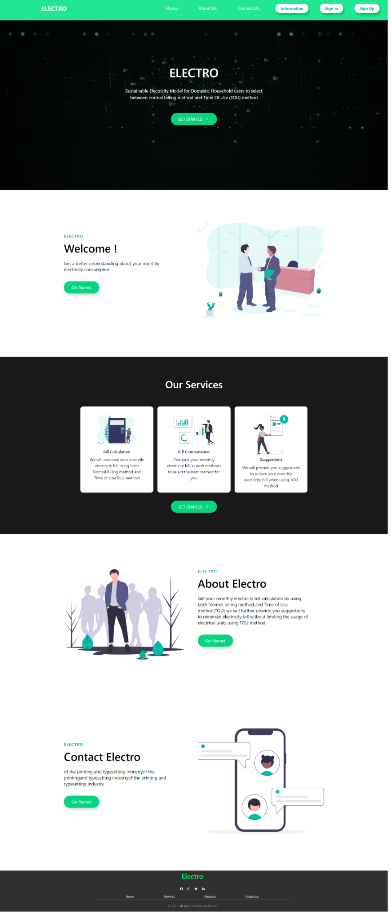

## 9.2 Customer

### 9.2.1 Dashboard

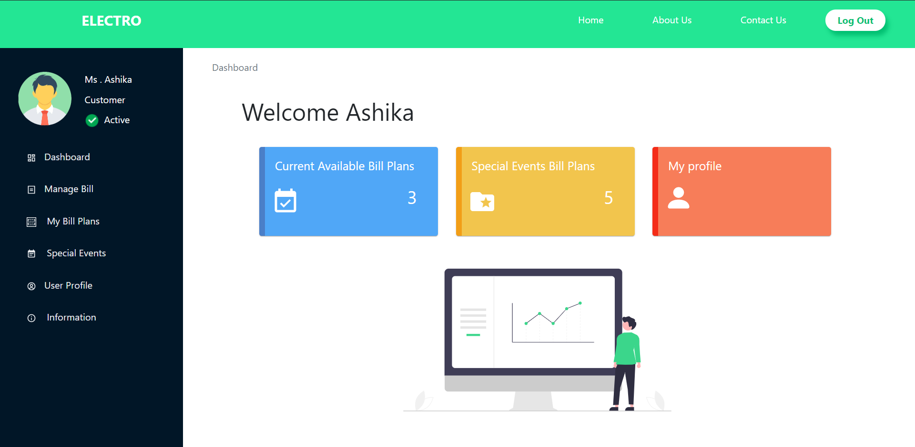

### 9.2.2 Creating a new bill plan

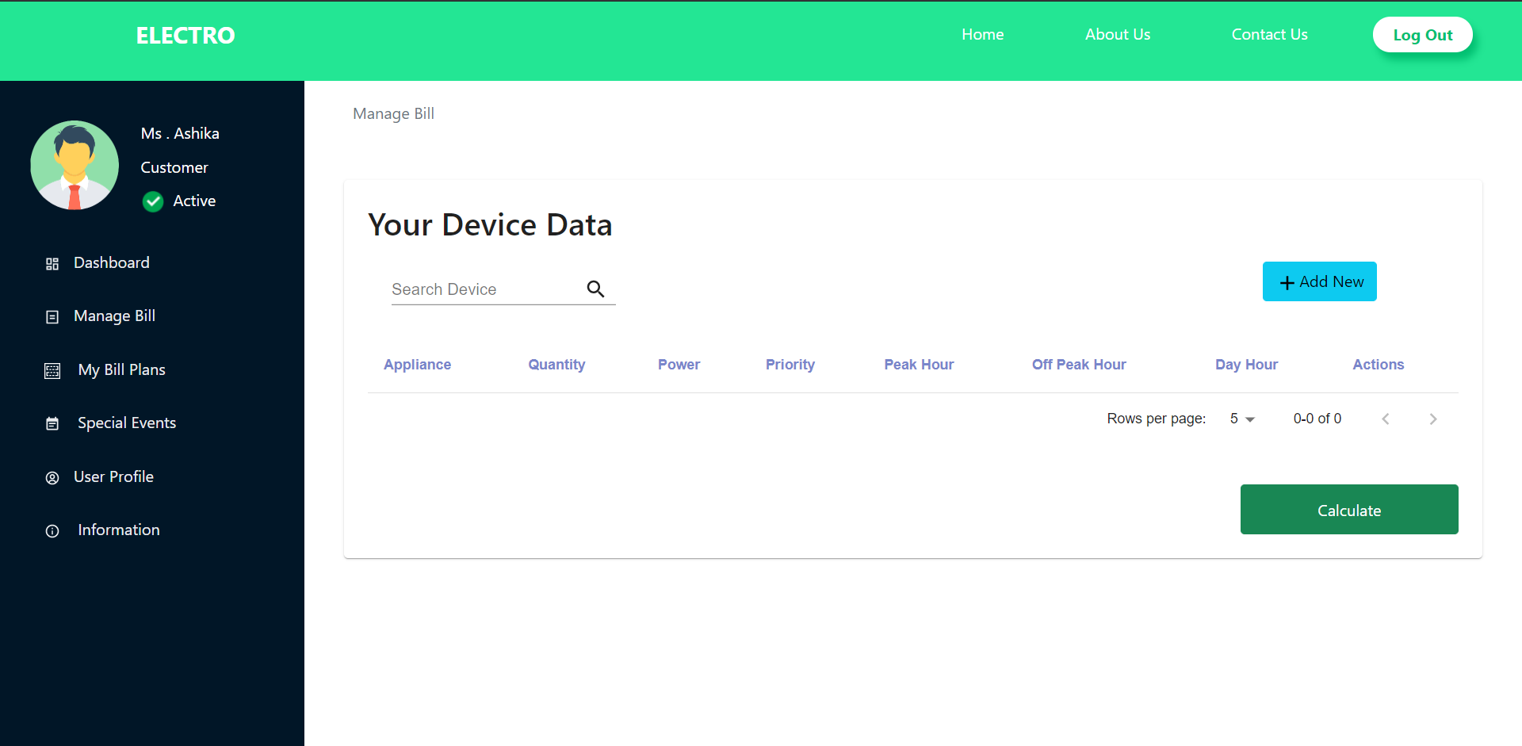

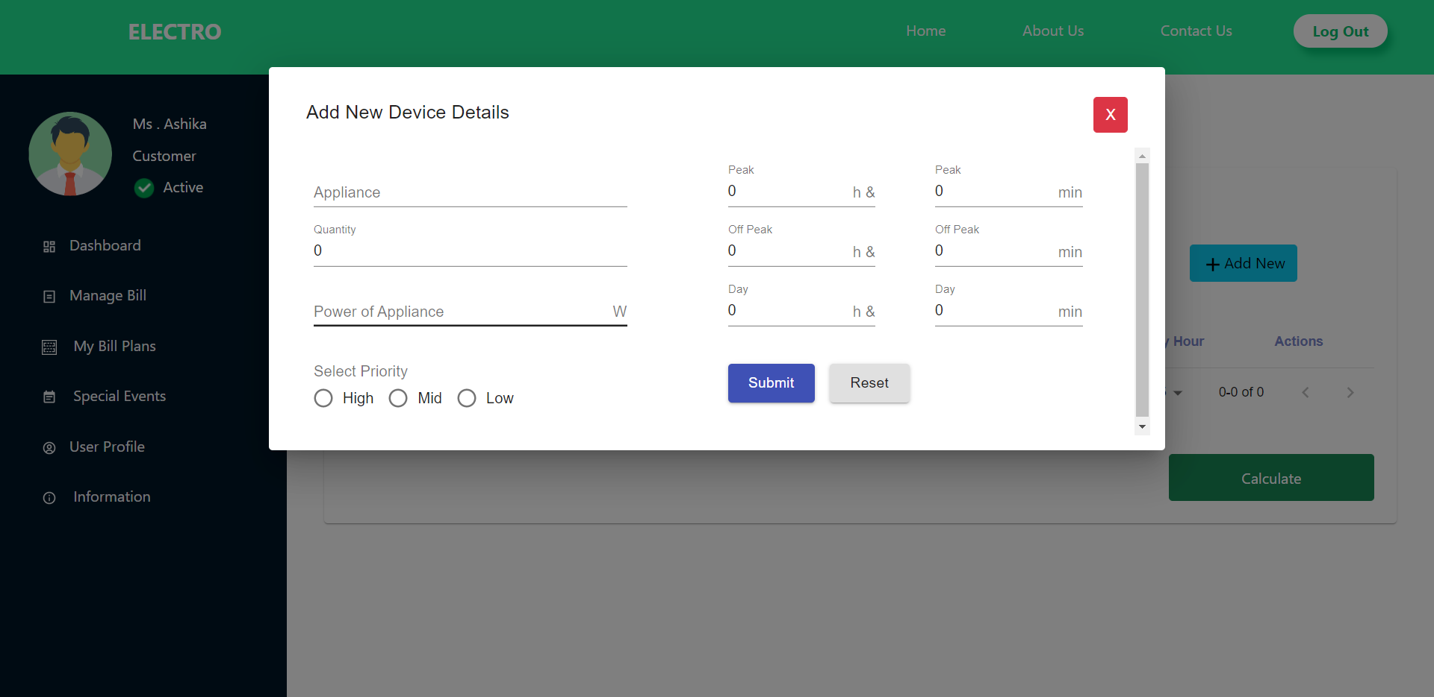

### 9.2.3 Bill Comparison

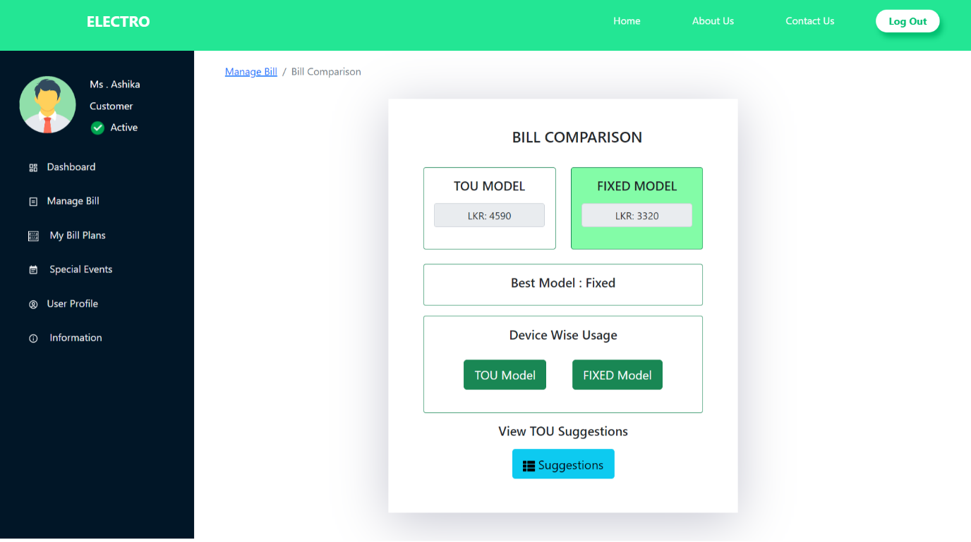

### 9.2.4 Devise Wise Usage

### TOU

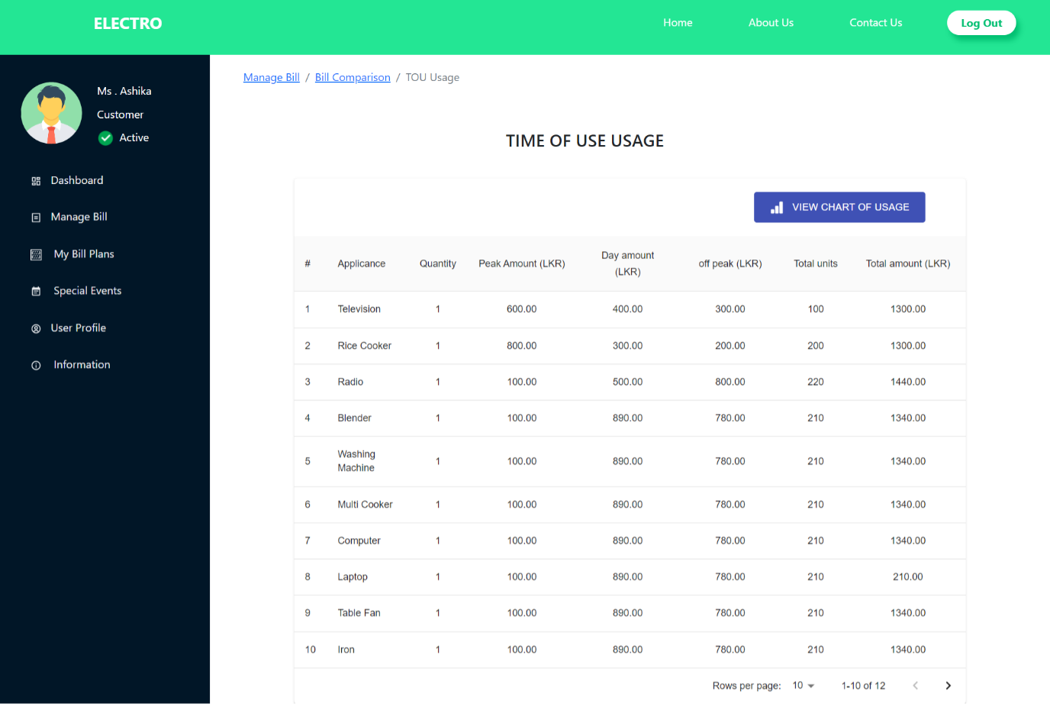

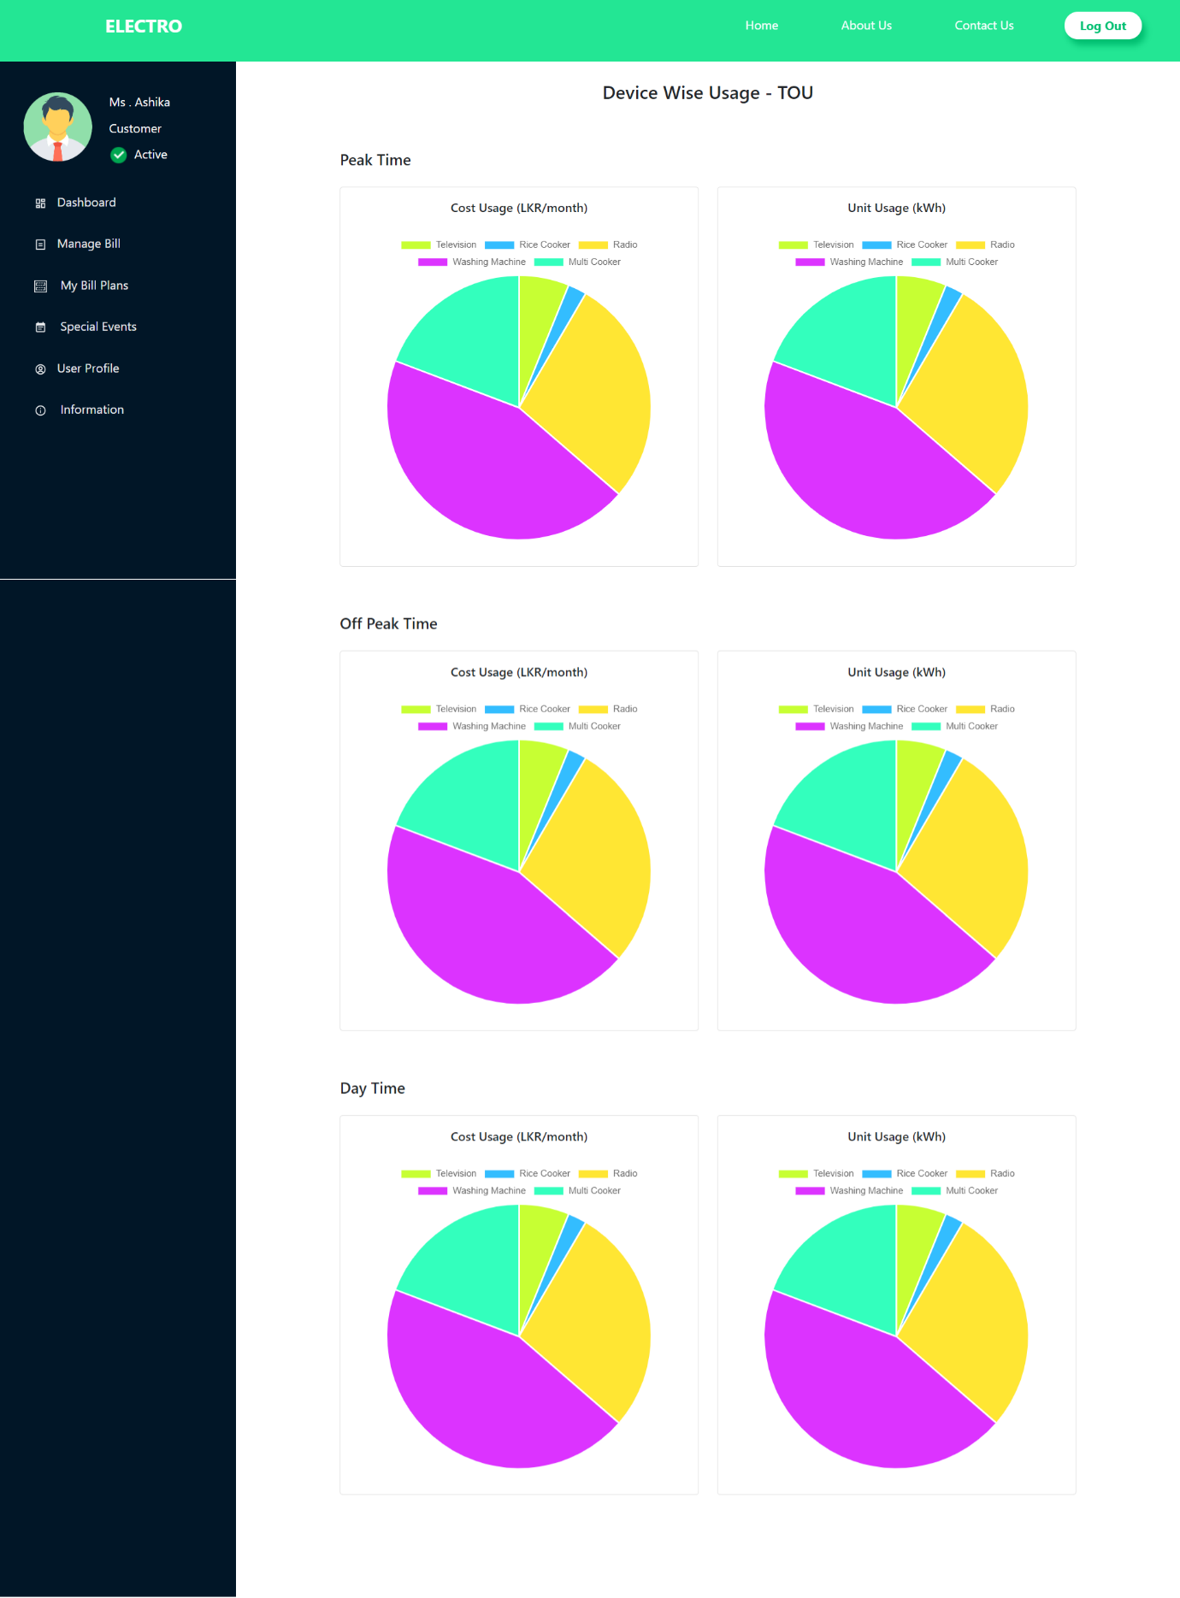

### Fixed

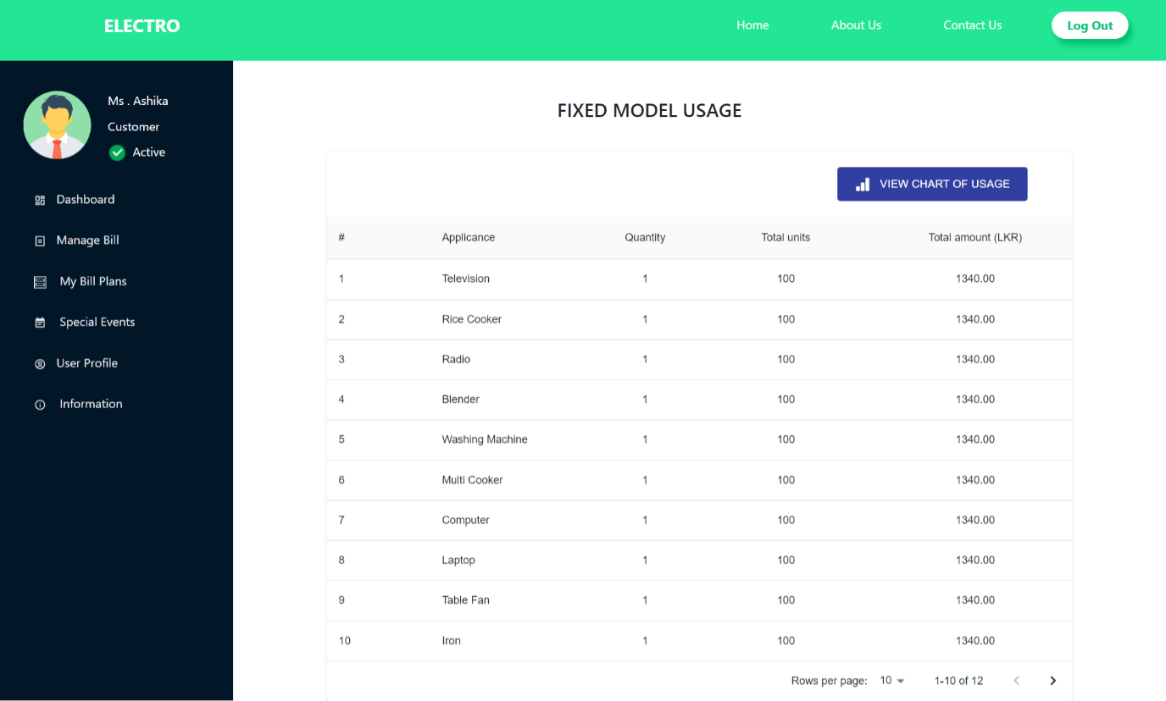

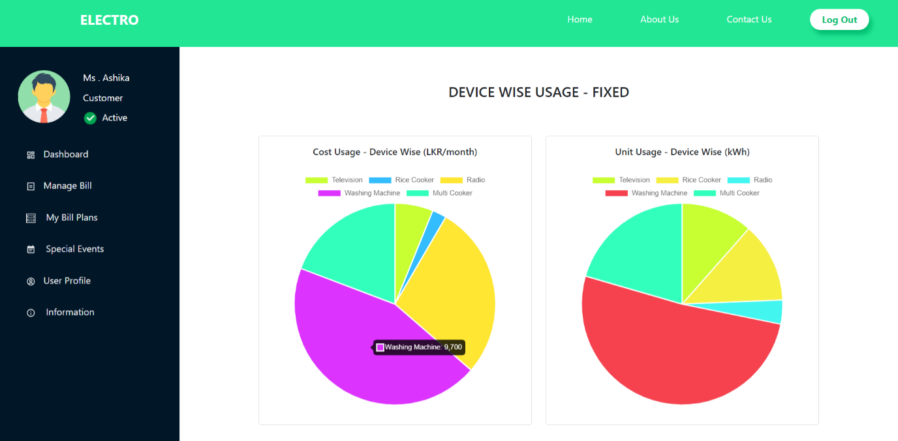

### 9.2.5 TOU Suggestions

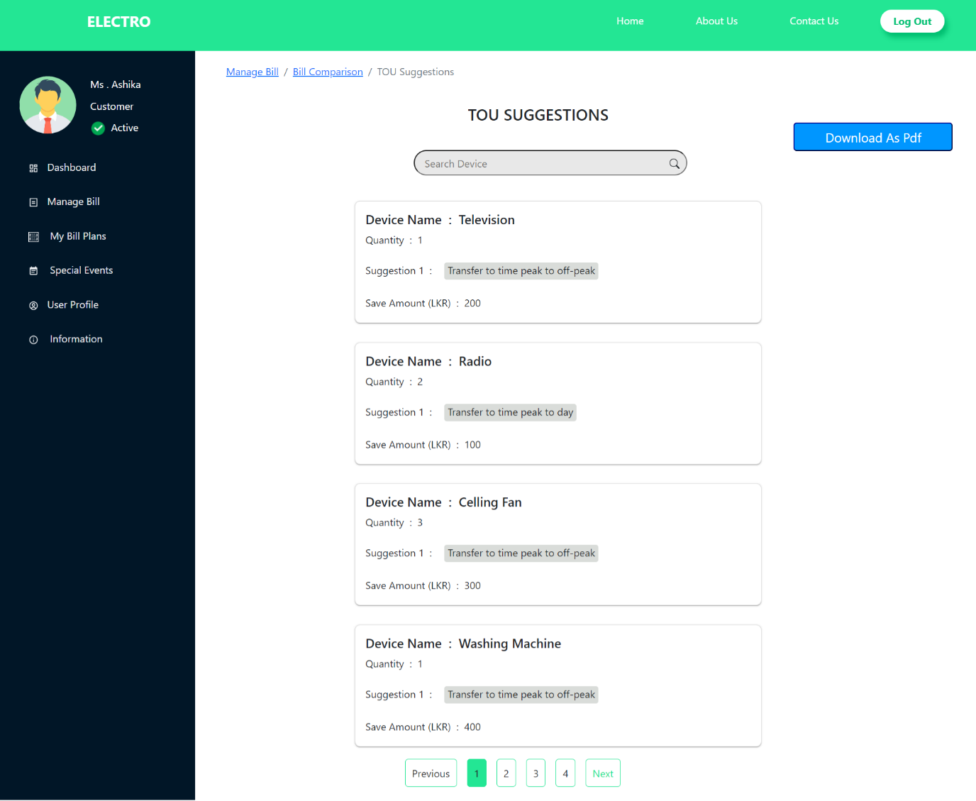

### 9.2.6 My Bill Plans

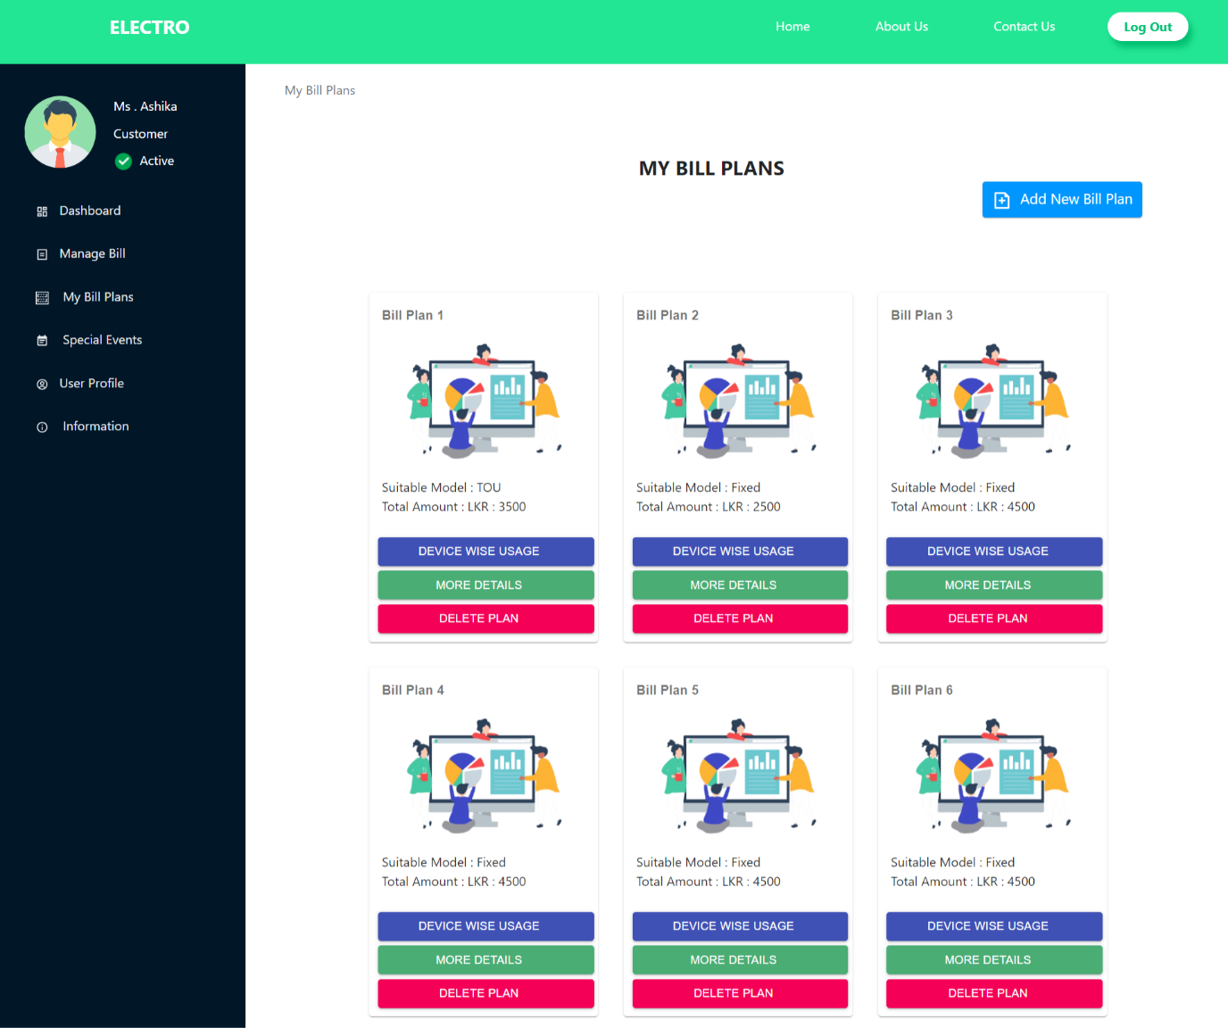

### 9.2.7 My Bill Plans-More Details

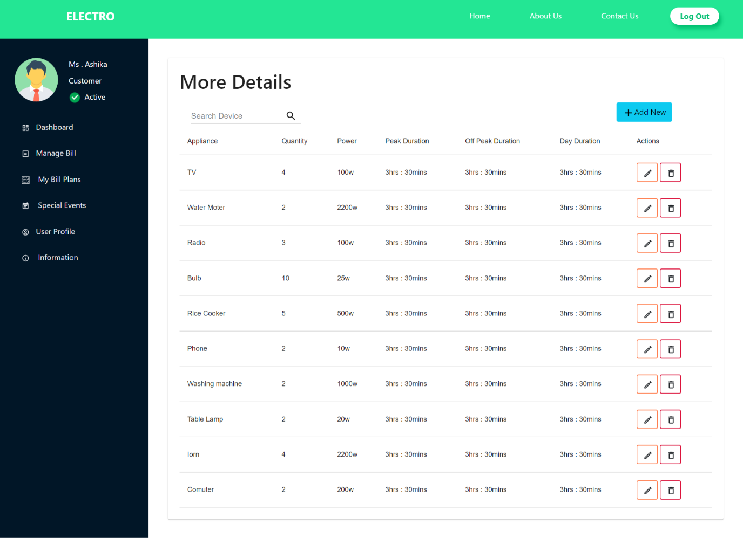

### 9.2.8 Special Events

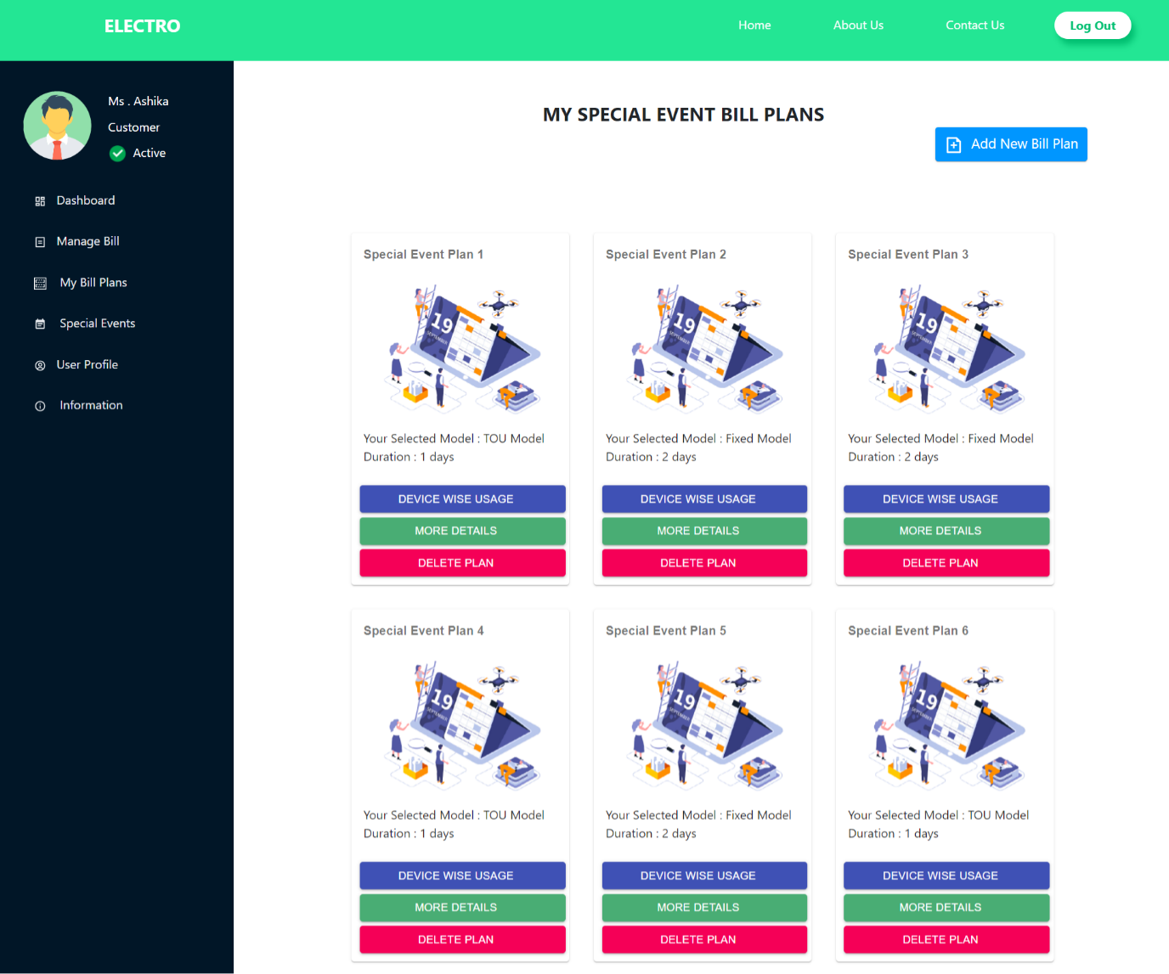

### 9.2.9 Special Events-More Details

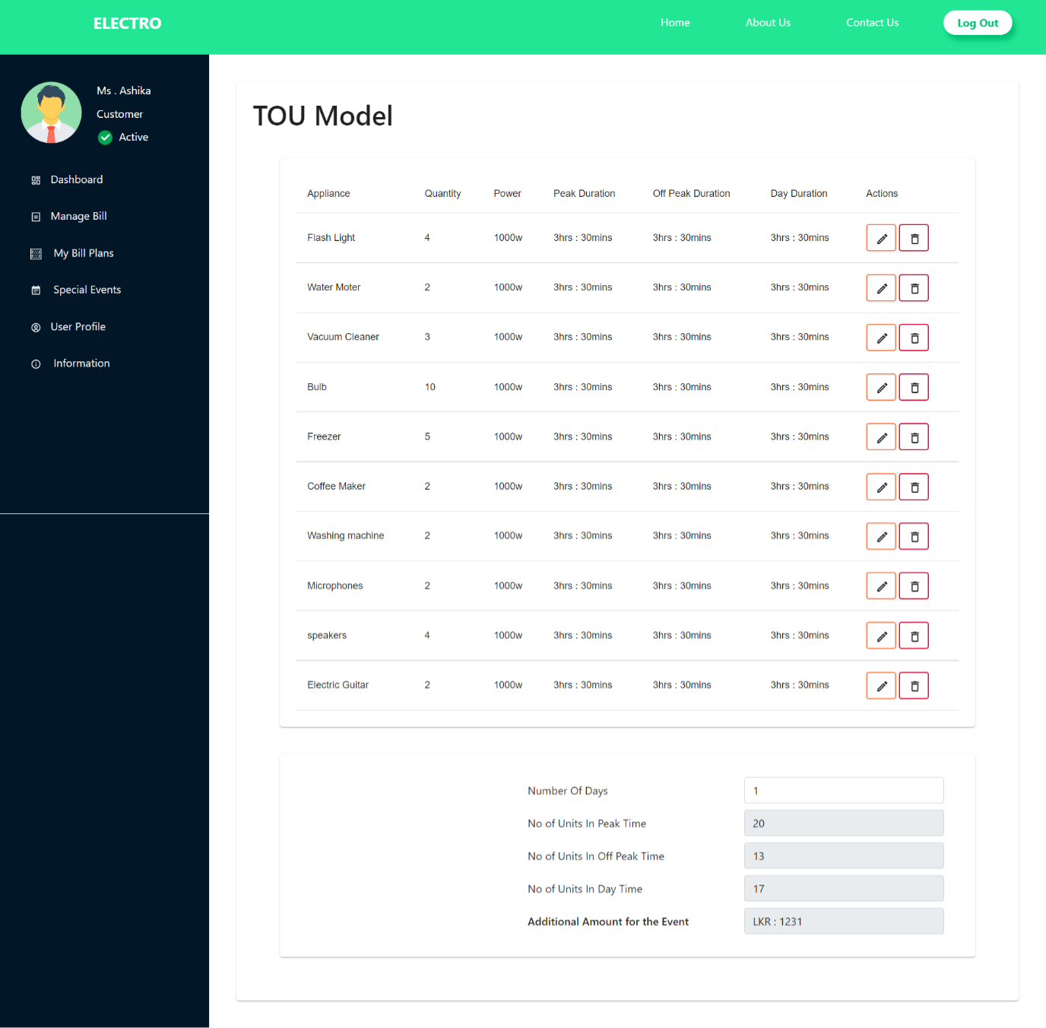

### 9.2.10 Information Page

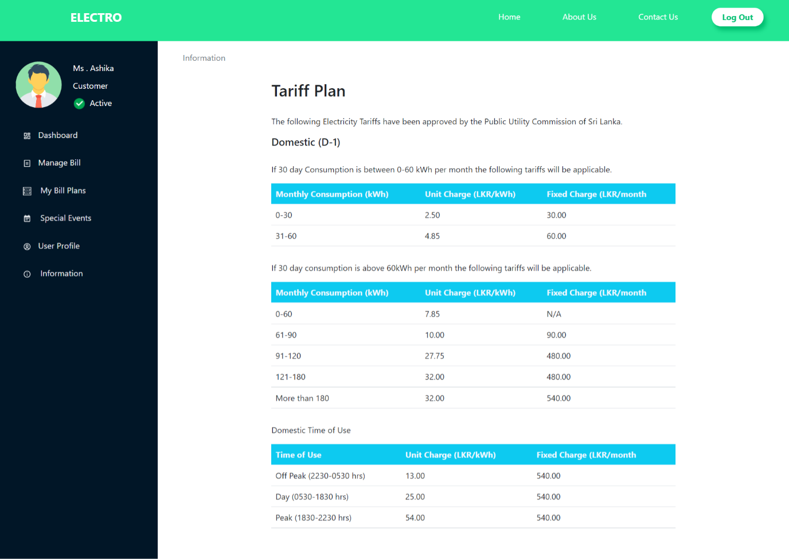

## 9.3 Admin

### 9.3.1 Dashboard

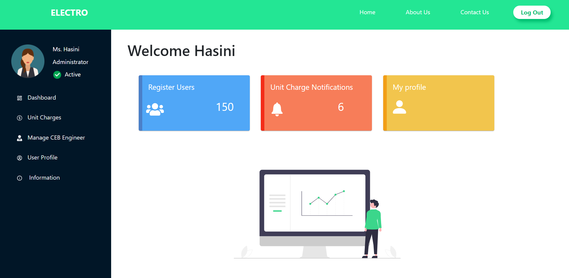

### 9.3.2 Managing Unit Charges Home

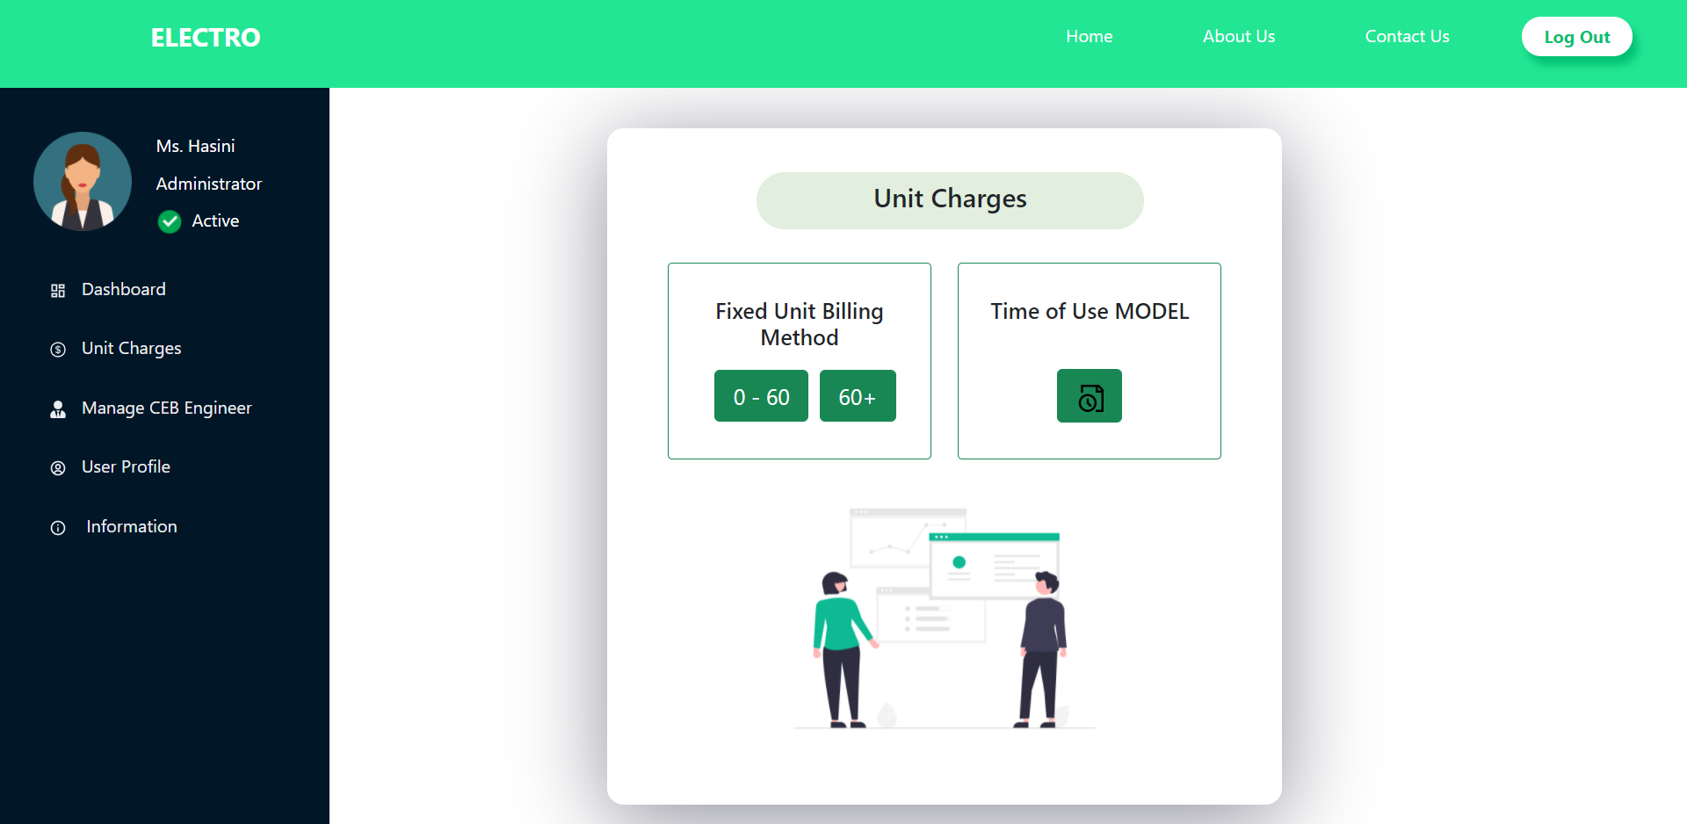

### 9.3.3 UI for updating unit charges

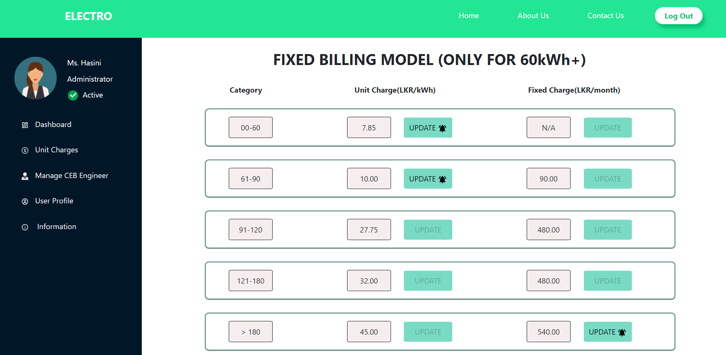

### 9.3.4 Pop up window when updating unit charges

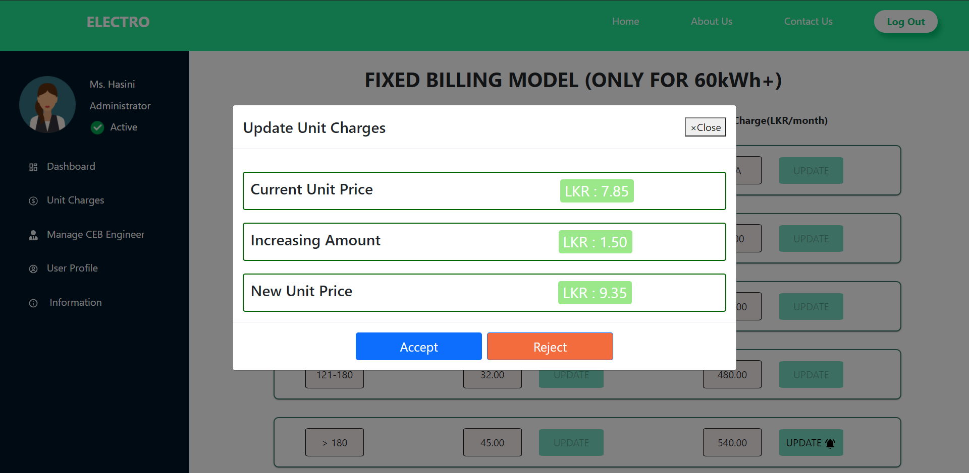

#### 9.3.5 Managing CEB Engineer

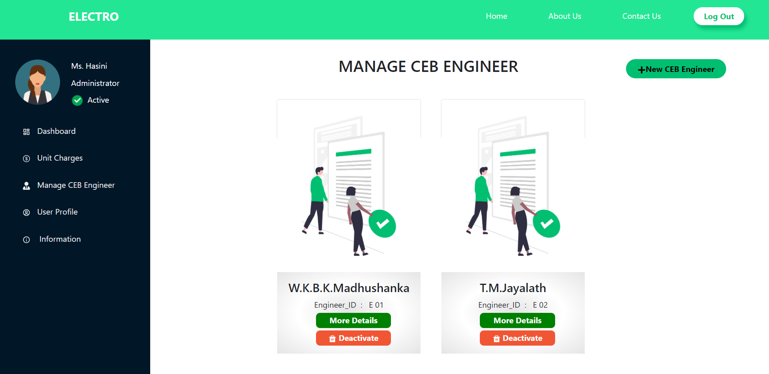

### 9.3.6 Updating CEB Engineer details

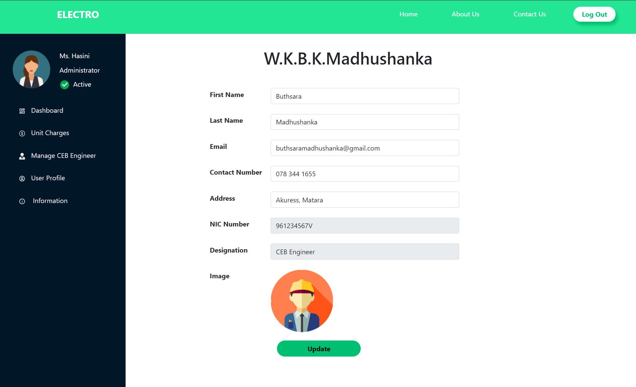

### 9.3.7 Updating User profile

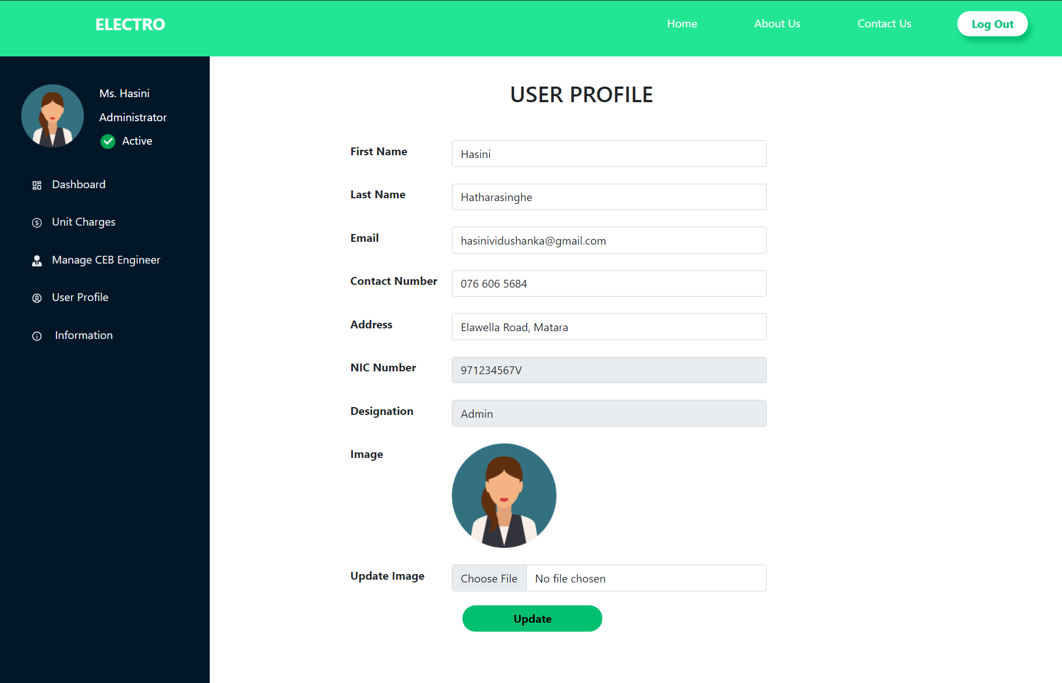

## 9.4 CEB Engineer

### 9.4.1 Dashboard

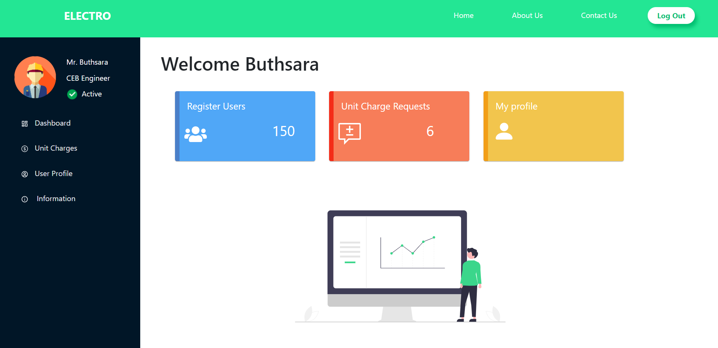

### 9.4.2 Pop up window when updating unit charges

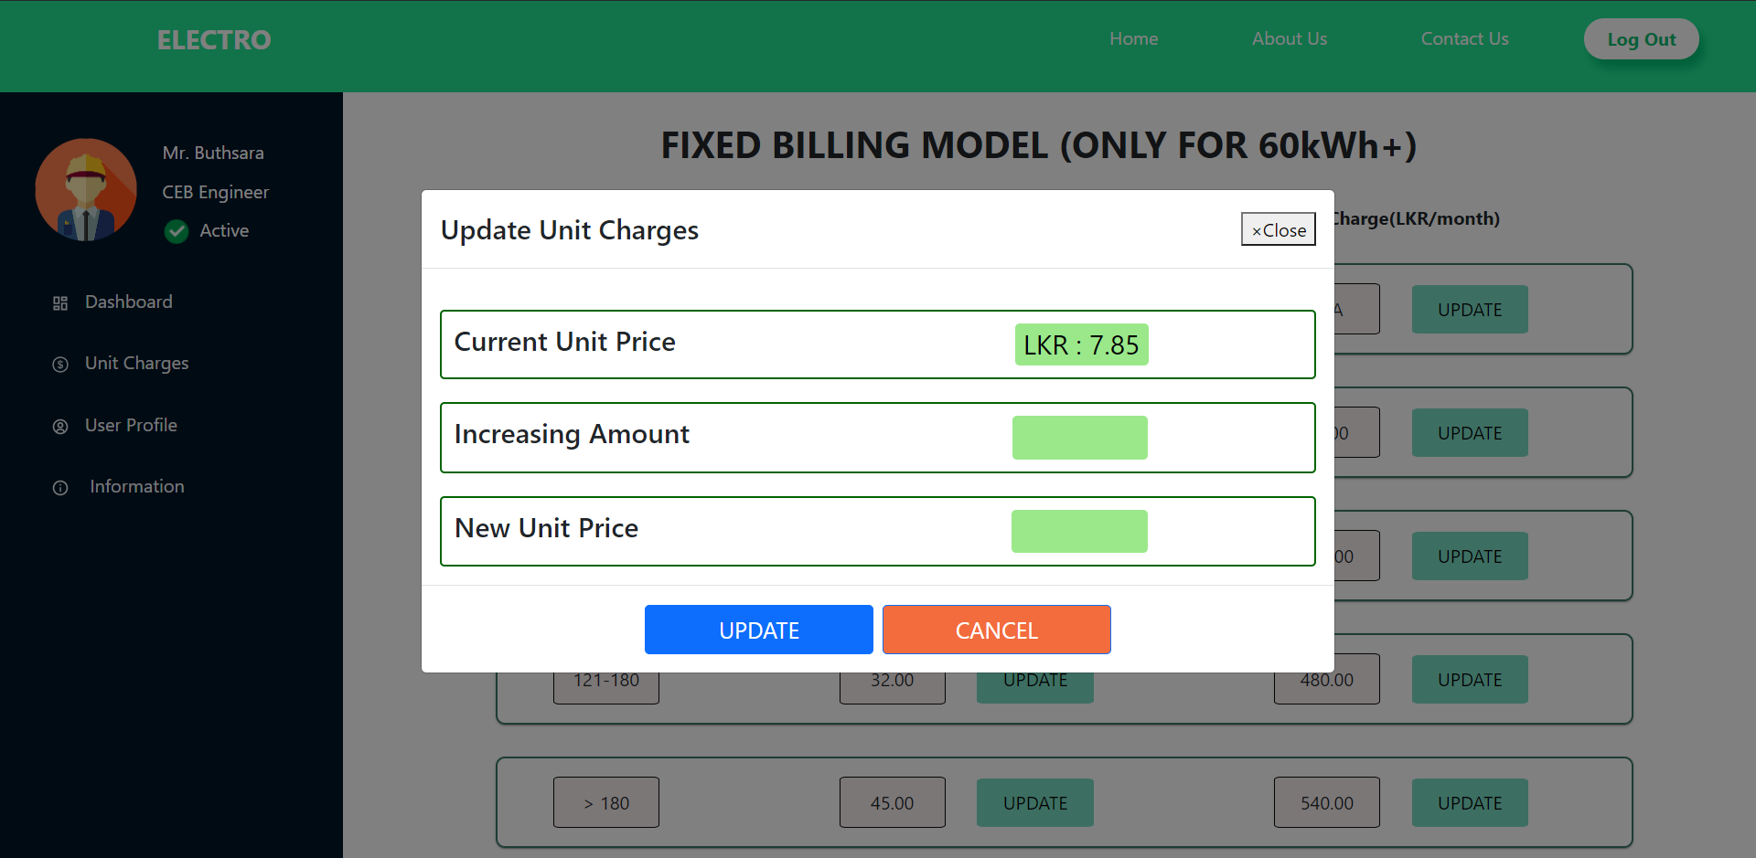

### User Profile

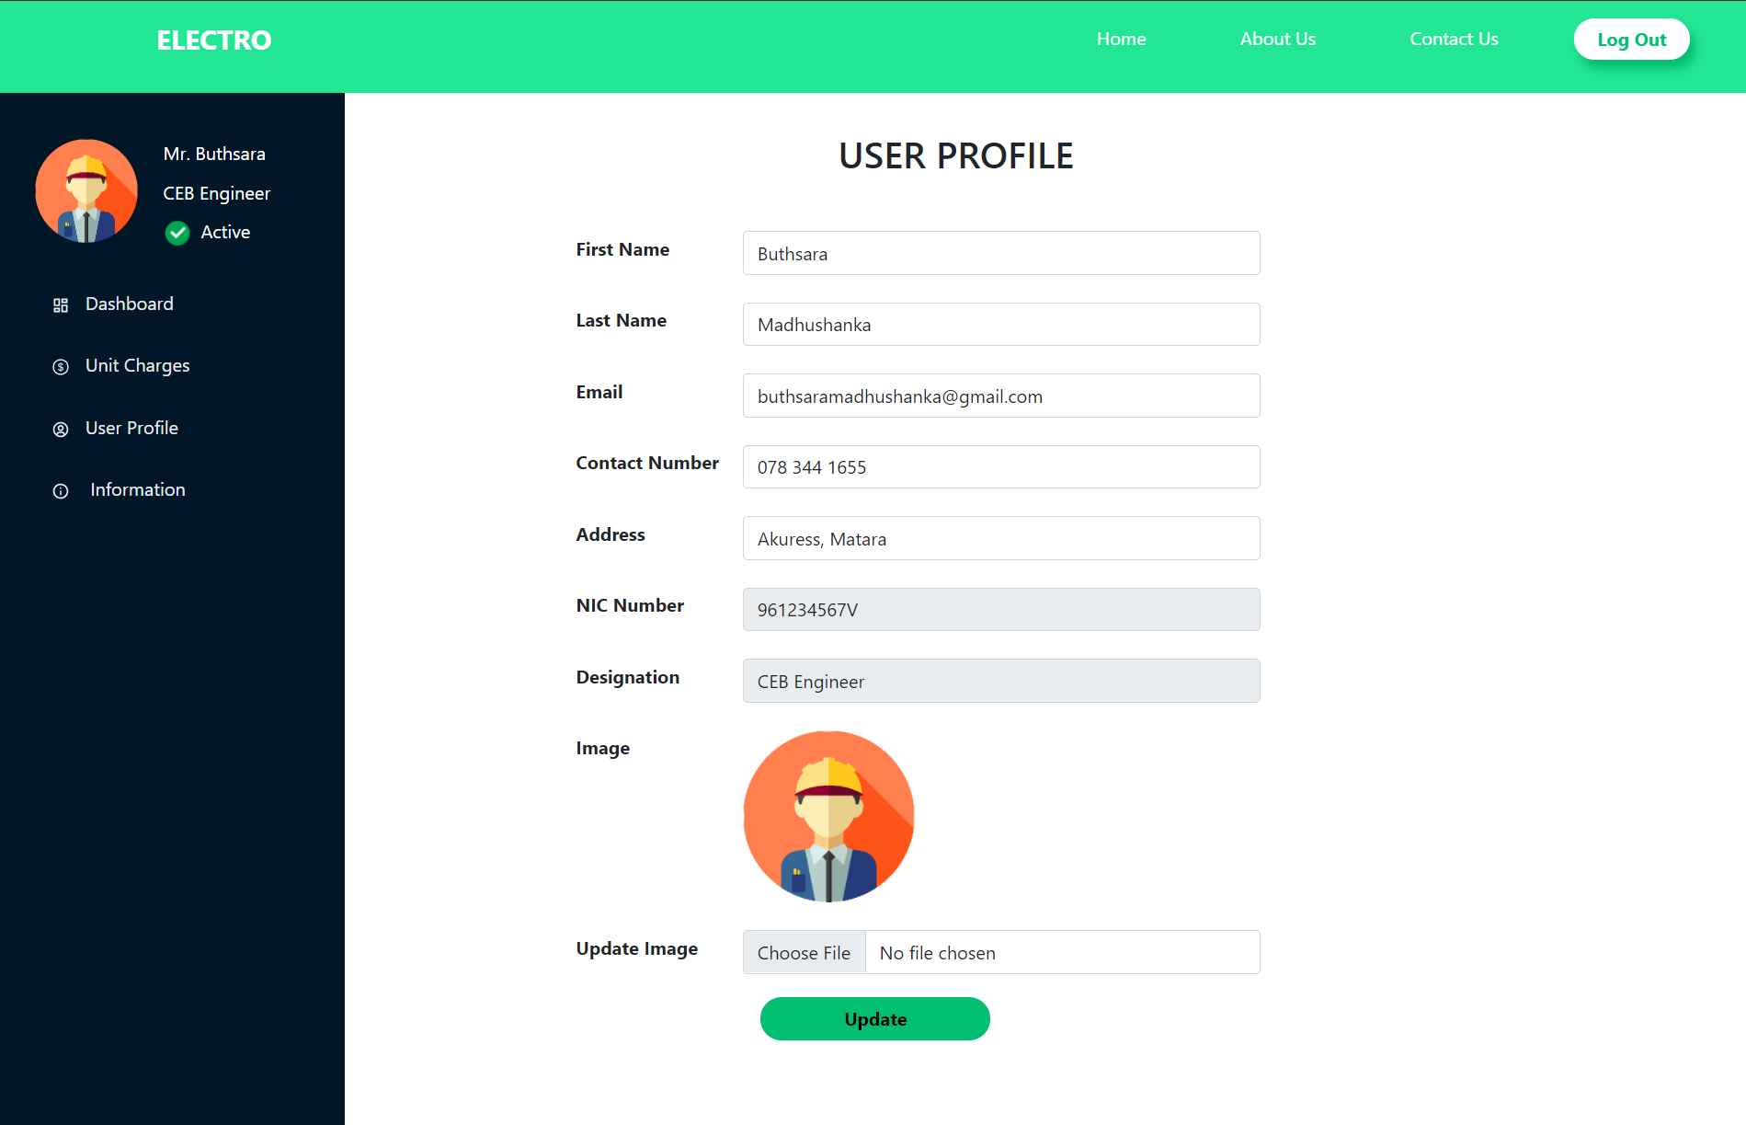

# Main deliverables of the system

1. Complete working Mobile Application and the source code
2. Complete working web Application and the source code
3. Complete Software Requirement Specification for both mobile and web application
4. License of the software

* React Js - Standard MIT License
* Node Js - MIT license
* Express Js - MIT License

# The Project Plan

Start Date: 10/05/2021

Estimated End Date: 05/09/2021

## Work Breakdown Structure

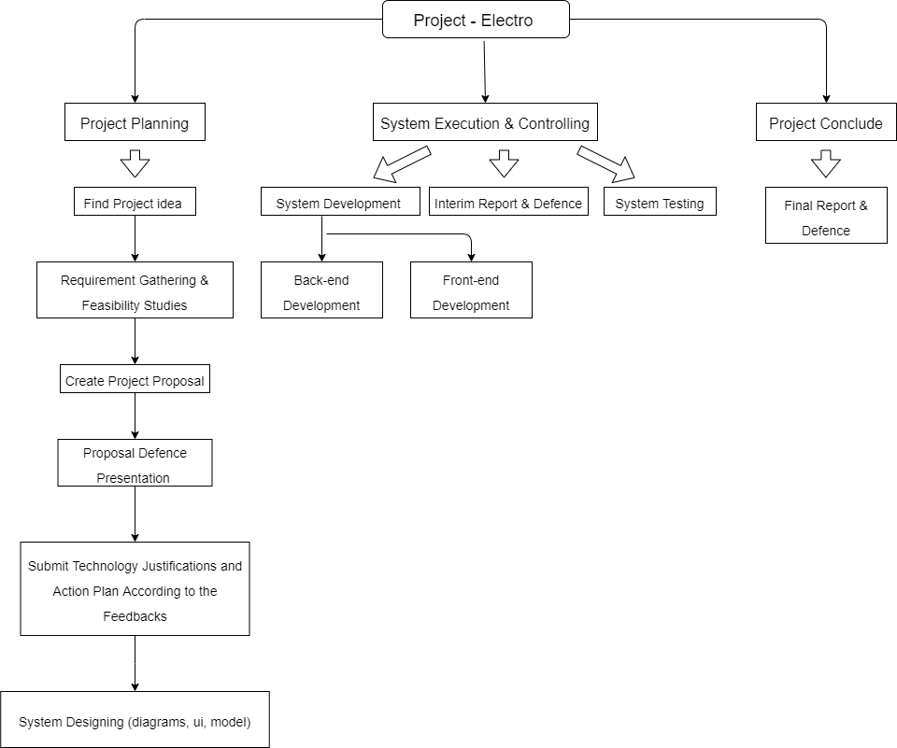

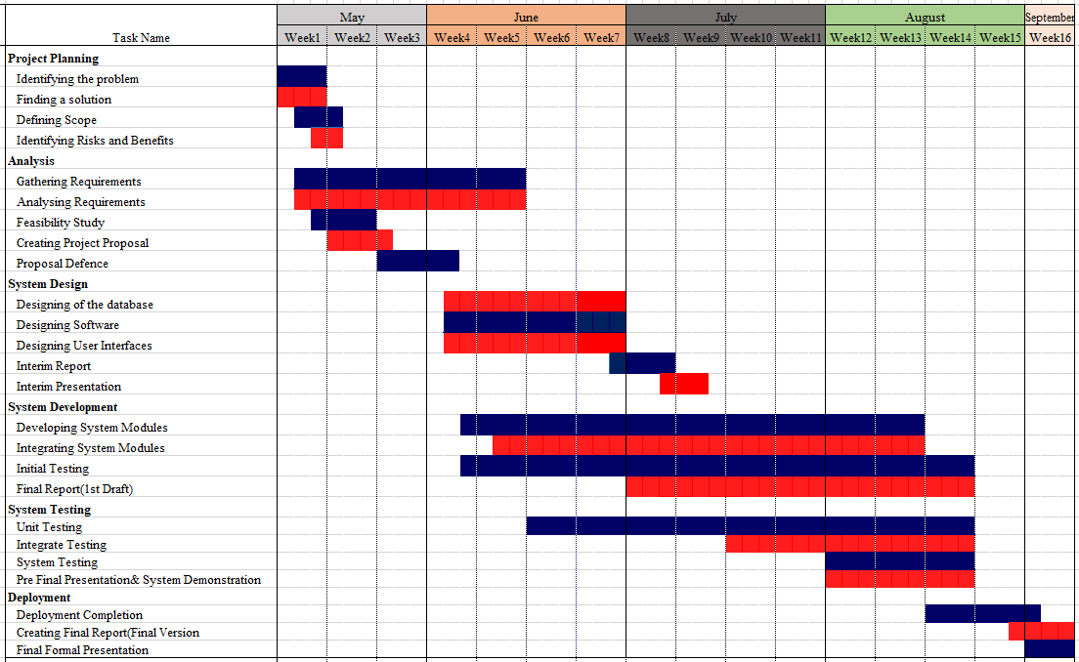

# 12) References

[1] Pucsl.gov.lk. 2021. *Electricity Tariff and Charges | PUCSL*. [online] Available at: <https://www.pucsl.gov.lk/electricity/tariff/electricity-tariff-and-charges/> [Accessed 14 May 2021].

[2] Leco.lk. 2021. *Tariff Plan*. [online] Available at: <https://www.leco.lk/pages_e.php?id=86> [Accessed 14 May 2021].

[3] Play.google.com. 2021. [online] Available at: <https://play.google.com/store/apps/details?id=com.ceb.lk.cebcare&hl=en&gl=US> [Accessed 15 May 2021].

[4] App.grammarly.com. 2021. *Grammarly*. [online] Available at: <https://app.grammarly.com/> [Accessed 10 May 2021].

[5] Figma. 2021. *Figma: the collaborative interface design tool.*. [online] Available at: <https://www.figma.com/> [Accessed 15 June 2021].

[6] Diagrams.net. 2021. *Diagram Software and Flowchart Maker*. [online] Available at: <https://www.diagrams.net/> [Accessed 15 June 2021].

# 13) Declaration

***We as members of the project titled “Electro-Sustainable Electricity Model for Domestic Users”, certify that we will carry out this project according to guidelines provided by the coordinators and supervisors of the course as well as we will not incorporate, without acknowledgment, any material previously submitted for a degree or diploma in any university. To the best of our knowledge and belief, the project work will not contain any material previously published or written by another person or ourselves except where due reference is made in the text of appropriate places.***

|  |  |
| --- | --- |
| ***Name*** | ***Signature*** |
| (i) T.W.T.Dulshan |  |
| (ii) W.M.D.M.Y.Wickramanayaka |  |
| (iii) A.V.Abeysuriya |  |
| (iv) W.K.B.K.Madhushanka |  |
| (v) H.A.H.Vidushanka |  |